Final Report of
Official Launch of Policy Dialogue Initiative for the National Digital Farmers Registry (NDFR) in Nigeria

Held at
Wells Carlton Hotel and Apartments, Asokoro, Abuja
on
Wednesday 28th May 28, 2025
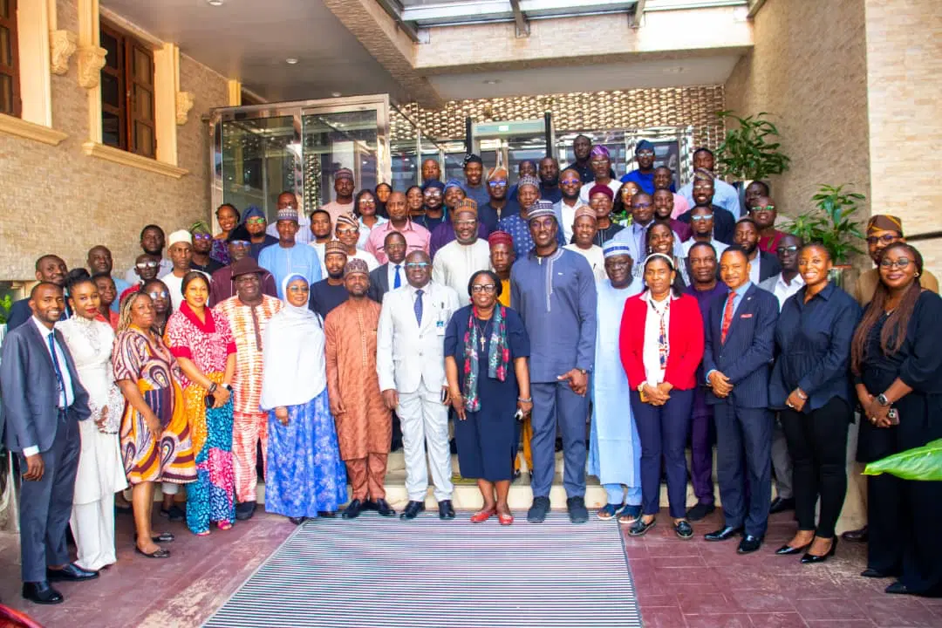

Outline
1.0 Executive Summary 3
2.0 Background 6
3.0 Proceeding from the Official Launch 7
3.1 Welcome Remarks 7
3.2 Opening Remarks Partnerships and Multi-Stakeholder Engagement 7
3.3 Presentation of the Policy Dialogue Initiative on National Digital Farmer Registry (NDFR) 7
3.4 Opening and Official Launch of Policy Dialogue Initiative on NDFR 7
3.5 Other Highlights from the Launch Remarks 8
3.5.1 Key Innovations: NEEP and NADMIS 8
3.5.2 Stakeholder goodwill messages, remarks and feedback 8
3.5.3 Insight from Stakeholder Feedback on Digital Farmer Databases 9
3.5.4 Questions and Insights 11
3.7 Key Recommendations 12
3.8 Next Steps for Immediate Action 13
4.0 Conclusion 14
Annexes 15
Annex 1 – Agenda for Official Launch Ceremony 15
Annex 2 – Speech of the Permanent Secretary 16
Annex 3 – Presentation Slides by Heifer Nigeria 19
Annex 4 – Workshop Documentation QR-Codes 26
Annex 5 - Questionnaire Responses 27
Annex 6 – Workshop Attendance 41

1.0 Executive Summary
The Policy Dialogue Initiative (PDI) for the National Digital Farmers Registry (NDFR) was officially launched by the Federal Ministry of Agriculture and Food Security (FMAFS), in collaboration with the International Fund for Agricultural Development (IFAD) and Heifer International. The launch event took place on May 28, 2025, at the Wells Carlton Hotel and Apartments in Abuja.
The Policy Dialogue Initiative aims to: a) Strengthen the capacity of key stakeholders in supporting and coordinating an effective, efficient, and sustainable Unified National Digital Farmers Registry (NDFR); b) Identify strategic recommendations to support the development and implementation of the NDFR; and c) Establish a multi-stakeholder platform to mobilize, coordinate, and integrate the contributions of key actors, including government, the private sector, civil society organizations, farmer organizations, and development partners.
The event brought together stakeholders from the Federal Ministry of Agriculture and Food Security (FMAFS), IFAD, Heifer International, farmer organizations, development partners, private sector actors, and various government ministries, departments, and agencies. This initiative represents a cornerstone of Nigeria’s strategy to transform its agricultural sector through digital innovation, in line with the National Agricultural Technology and Innovation Policy (NATIP) and the Digital Innovation Action Plan (DIAP).
The official launch was marked by an opening speech from the Minister of FMAFS, delivered on his behalf by the Permanent Secretary of the Ministry Dr. Marcus O. Ogunbiyi, alongside remarks by the Country Director (CD) of IFAD, Mrs. Dede Ekoue and a presentation on building strong partnerships and coordination for the NDFR by the CD of Heifer International, Nigeria, Dr. Lekan Tobe. Goodwill messages were also delivered by representatives from the Food and Agriculture Organization of the United Nations (FAO) and the African Development Bank (AfDB).
In his speech, the Permanent Secretary emphasized that stakeholders’ “…diverse perspectives and active participation are not only valued but essential to the success of this initiative.” He added, “As we are all aware, agriculture remains the backbone of Nigeria's economy — not just in terms of employment and livelihoods, but also in its potential to drive food security, industrial development, and export revenue. Yet, for far too long, our efforts to transform the sector have been hampered by a lack of reliable data, especially on the key actors — our farmers.” He further remarked, “The Digital National Farmers' Registry is a transformative initiative that seeks to capture accurate, real-time, and geo-referenced data on farmers across the country — disaggregated by location, commodity, scale of production, gender, and age. This registry is more than a database; it is a strategic tool for promoting inclusion, transparency, and measurable impact.” He concluded by noting that, “The implementation and sustainability of the Digital Farmers' Registry will benefit immensely from such partnerships — not only in terms of funding, but also in technical design, knowledge transfer, institutional capacity-building, and inclusive governance mechanisms. Our collaboration with IFAD and similar institutions ensures that the registry is not just a database, but a living tool aligned with global best practices and tailored to local realities.”
The Launch of the Policy Dialogue Initiative also featured consultations on the Farmer Registry (FR) with Ministries, Departments and Agencies (MDAs), the private sector, civil society, development partners, and farmer organizations. Other activities included the presentation of results from a rapid assessment of farmer databases in Nigeria. Stakeholders were also provided with key background documents for the NDFR and related digitalization efforts, including: a) Nigeria's National Pathways to Food Systems Transformation; b) Presidential Emergency Declaration on Nigeria’s Food Security; c) Report of Exchange Visit on ICT4D to KCEP–CRAL, Nairobi, Kenya; d) ICT4D Workshop Report: Multistakeholder Strategic Dialogue on Scaling Up ICT4D for the Empowerment of Smallholder Farmers; e) National Agricultural Technology and Innovation Policy (NATIP) 2022–2027; f) Needs Assessment Study for Agricultural Digitalization in the Context of IFAD–Nigeria Cooperation; g) Proceedings of the National Policy Dialogue on Deepening Partnership for Scale-Up of ICT4D for Smallholder Farmers in Nigeria; and h) DAS ICT4Ag: Monitoring and Evaluation Training Final Report.
In addition, consultations with key stakeholders from MDAs, Farmer Organizations (FO), Development Partners and Private Sectors — including FMAFS, FMBEP, NPC, NBS, NADRDA, BOA, NIMET, PROPCOM+, Lapo Microfinance Bank, IFAD, Heifer International, AfDB, FAO, GIZ the Tony Blair Institute, and other — underscored the importance of the PDI while also identifying several challenges that must be addressed. These include fragmented and uncoordinated farmer data, the absence of standardized protocols, limited digital infrastructure, and insufficient financial and technical resources. Concerns were also raised regarding digital literacy among smallholder farmers, particularly those in remote areas, which may hinder effective participation in digital registration systems.
To address these needs, all institutions expressed interest and commitment to support the process of developing a unified National Digital Farmers Registry (NDFR). As next steps, several recommendations were made, including the following:
- Stakeholder Mobilization on Common Understanding of Farmer Registry: The Federal Ministry of Agriculture and Food Security (FMAFS) should mobilize key stakeholders to build a shared understanding of the planned pilot initiative of the farmer registry. This is critical for facilitating their involvement, especially in pilot states such as Nasarawa and Kogi. Stakeholders should be notified well in advance to ensure meaningful participation. Importantly, the process must adopt a farmer-centric approach to ensure the active participation and buy-in of farmers.
- Capacity Building on Global Best Practices: A training program on global best practices for farmer registries should be conducted. This capacity building should include webinars and workshops to equip stakeholders with the knowledge and tools needed to effectively support the NDFR, with a focus on the design, maintenance, and utilization of farmer databases. The training should facilitate the common understanding of benchmarks used for assessing farmer database and registry.
- Assessment of Digital Farmer Database and Registry: Building on the initial rapid overview, a comprehensive assessment should be conducted to examine existing digital farmer databases and digital infrastructure used in agriculture. The goal is to generate strategic recommendations that will inform the final design and ensure successful implementation of the NDFR, particularly in enabling the deployment of digital solutions for smallholder farmers.
- Validation and Adoption of Strategic Recommendations: A validation report should be developed from the assessment of existing farmer registries and databases, and strategic recommendations should be presented for adoption. These recommendations should take into account key best practices including: a) An inclusive and compliant governance framework, including agreed data formats, specifications, usage guidelines, and data protection/privacy measures; b) Interoperable linkages between the NDFR and other use cases; c) Efficient mechanisms for the design and regular updating of the NDFR respecting the specific mandates of each stakeholder; d) A participatory, realistic and efficient national scale-up strategy, building on ongoing initiatives across states; e) Sustainable financing mechanisms for the development and maintenance of the NDFR; and
f) Leveraging the NDFR to catalyze investments and intensify the deployment of digital solutions that benefit smallholder farmers in Nigeria.
- Support for a Multi-Stakeholder Platform in Continued Policy Dialogue on NDFR: A multi-stakeholder platform should be supported to coordinate and integrate the contributions of key stakeholders, including government, the private sector, civil society, farmer organizations, and development partners. This alliance will be instrumental in ensuring the accelerated and sustainable implementation of the NDFR. It will also enhance the registry’s value by: a) Supporting smallholder farmers through scaled investments and digital solutions; b) Informing policy-making processes; c) Enhancing monitoring of policy impacts and program outcomes; d) Improving coordination among programs for optimized resource use and higher return on investment; and e) Increasing visibility and accountability of agricultural development initiatives.
- Effective Mobilization of Financial and Technical Support: Coordinated mobilization of financial and technical support is essential for the comprehensive design and implementation of the NDFR. This should involve: a) Ministries, Departments, and Agencies (MDAs); b) International development partners; c) Private sector actors; and d) Civil society initiatives.
The launch workshop led to several key outcomes, including: a) A shared understanding among stakeholders of the Policy Dialogue Initiative for the NDFR; b) Ownership of the Policy Dialogue implementation strategy in support of the NDFR; c) Commitment from key stakeholders to contribute towards the successful implementation of the initiative for a unified NDFR; d) Strategic recommendations for the continued implementation of the Policy Dialogue Initiative; e) Proposals to strengthen the rollout of the NIN-enabled NDFR coordinated by FMAFS; and f) Greater visibility and appreciation of ongoing efforts to build farmer databases, along with recognition of the need for continued information exchange and synergy among key stakeholders.
Finally, the launch of the Policy Dialogue Initiative for the NDFR, under the leadership of the Federal Ministry of Agriculture and Food Security, marks a significant milestone toward the realization of a unified national registry. This registry is expected to drive greater efficiency, transparency, and impact across Nigeria’s agri-food systems. It will facilitate the scaling up of investments and the deployment of digital tools essential for food systems transformation, in alignment with national priorities and the Kampala Declaration which recognizes the transformative impact of technological innovations and advances in digital agriculture through digitalization including digital platforms like the NDFR.

2.0 Background
The Federal Ministry of Agriculture and Food Security (FMAFS) and the International Fund for Agricultural Development (IFAD) in collaboration with Heifer International Nigeria organized the official launch of the Policy Dialogue Initiative on the National Digital Farmers Registry (NDFR). Key Ministries, Departments and Agencies (MDAs), private sector, farmer organizations and development partners participated in this Official Launch. This Launch took place at Wells Carlton Hotel and Apartments, Asokoro, Abuja and officially opened at 9:00am.
The launch of the Policy Dialogue is part of the Federal Government of Nigeria and the International Fund for Agricultural Development’s (IFAD) ongoing commitment to sustainable agricultural transformation through the National Agriculture Technology and Innovation Policy (NATIP) and the Collaboration document, Digital Innovation Action Plan (DIAP) between the Federal Government of Nigeria and IFAD leveraging the Digital Ecosystem Assessment which highlights the importance of digital innovations for the transformation of food systems and empowerment of smallholder farmers. In line with this policy priority, the Federal Ministry of Agriculture and Food Security (FMAFS) and IFAD in collaboration with other key stakeholders undertook several strategic initiatives including:
- Rapid assessment of the existing ICT4D solutions available within the IFAD Nigeria Portfolio Programmes,
- Digital Agriculture Ecosystem Assessment,
- Multi-stakeholder Strategic Dialogue on Scaling up ICT4D for the empowerment of smallholder farmers,
- ICT4D Online Trainings on Principles for Digital Development and Digital Agriculture Ecosystem and Interoperability for about 68 participants,
- ICT4D Monitoring and Evaluation Training of 70 project staff and relevant government stakeholders,
- National Policy Dialogue on Deepening Partnership for scale-up of ICT4D for smallholder farmers in Nigeria.
The Specific Objectives of the Policy Initiative on NDFR targets to i) Strengthen the capacity of key stakeholders in supporting and coordinating an effective, efficient and sustainable Unified (NDFR), ii) identify strategic recommendations in support of a Unified National Digital Farmers Registry, and iii) set up a multistakeholder platform to mobilize, coordinate and integrate the contribution of key stakeholders including government, private sector, civil society organizations, farmer organizations and development partners in support of Unified National Digital Farmers Registry.
The Official Launch Workshop achieved the objectives of: a) Sensitization and awareness creation about the Policy Dialogue Initiative on National Digital Farmers Registry. b) Facilitation of stakeholders’ contributions on the implementation strategy of the National Digital Farmers Registry, and c) Promotion of stakeholders’ commitment to support the implementation of Policy Dialogue initiative for a Unified National Digital Farmers Registry.
Through these objectives, the outcomes below were achieved:
- Stakeholders’ common understanding of the Policy Dialogue initiative on National Digital Farmers Registry.
- Ownership of the implementation strategy of the Policy Dialogue initiative in support of the National Digital Farmers Registry.
- Commitment of key stakeholders to contribute to the successful implementation of the Policy Dialogue initiative for coordinated efforts towards a Unified National Digital Farmers Registry.

3.0 Proceeding from the Official Launch

3.1 Welcome Remarks
Mr. Aliyu Agwai, the Deputy Director for Research and Statistics of the FMAFS- Nigeria warmly welcomed everyone to the official launch of Policy Dialogue Initiative for the NDFR. He emphasized the long-standing partnership existing between the Federal Government of Nigeria and the International Fund for Agricultural Development (IFAD). He welcomed the participants and appreciated their presence. He added that he is looking forward to their contributions in shaping the future of the NDFR.

3.2 Opening Remarks Partnerships and Multi-Stakeholder Engagement
The Country Director of IFAD in Nigeria, Mrs. Dede Ekoue, in her opening remarks highlighted that the policy dialogue initiative is an outcome of previous consultations, technical assistance missions, and knowledge exchange programmes. Among them was a learning visit to Kenya and the ecosystem assessment of agricultural digitalisation in Nigeria. Mrs. Ekoue emphasized that partnership is the cornerstone of the policy dialogue and called for collective stakeholder engagement in actualizing a harmonised, functional national farmer registry.

3.3 Presentation of the Policy Dialogue Initiative on National Digital Farmer Registry (NDFR)
Dr. Lekan Tobe, Country Director of Heifer International, presented the significance of a data-driven policy implementation and equitable resource allocation. He pointed to the initiative’s alignment with the National Agricultural Technology and Innovation Policy (NATIP) and Kampala Agreement as the driving baseline for the initiative and outlined key objectives: capacity building, developing strategic partnerships, and launching a multi-stakeholder platform. He further reiterated the numerous benefits of the Policy Dialogue Initiative for Nigeria’s agricultural sector, including:
- Targeted service delivery: Enhanced precision in delivering inputs, financial inclusion, extension services, and digital technologies.
- Inclusion and equity: Ensuring smallholders, women, youth, and vulnerable groups are captured and supported.
- Transparency and efficiency: Eliminating ghost beneficiaries and improving G2P service delivery.
- Innovation and resilience: Supporting climate-smart agriculture, precision farming, and insurance uptake.
- Private sector engagement: Providing agribusinesses with traceable and credible farmer data.

3.4 Opening and Official Launch of Policy Dialogue Initiative on NDFR
In his opening remarks at the policy dialogue, Dr. Marcus O. Ogunbiyi, the Permanent Secretary of the Federal Ministry of Agriculture and Food Security (FMAFS), emphasized the necessity of reliable, geo-referenced, and disaggregated farmer data for inclusive planning and effective service delivery. The Digital National Farmers’ Registry, he noted, is designed not merely as a data repository but as a strategic governance tool for evidence-based planning, targeting, inclusion, and measurable impact in the agricultural ecosystem.
According to Dr. Ogunbiyi, the initiative will empower stakeholders—including financial institutions, agribusinesses, insurers, and development actors—to interact with farmers in a more precise and accountable manner. Notably, the registry incorporates integration with the National Identification Number (NIN) through a strategic partnership with the National Identity Management Commission (NIMC), ensuring each farmer is uniquely identified and connected to government-to-people (G2P) services.

3.5 Other Highlights from the Launch Remarks

3.5.1 Key Innovations: NEEP and NADMIS
The Ministry the Permanent Secretary mentioned significant steps needed to strengthen its digital agricultural ecosystem. The launch of the National Electronic Extension Platform (NEEP) in March 2025 marks a new era of extension delivery through digital means. This platform will interoperate with the National Farmers’ Registry, streamlining service provision and research linkages.
Additionally, the Ministry is developing the National Agricultural Data Management and Information System (NADMIS) as a centralized platform for harmonizing data across departments and projects. Once operational, NADMIS will bolster strategic planning and responsiveness by providing a unified and interoperable data system.

3.5.2 Stakeholder goodwill messages, remarks and feedback
Heifer International offered both financial and technical support for digital agriculture innovations. The organization emphasized the need for harmonization of farmer databases, noting that uncoordinated profiling efforts are leading to duplication and inefficiency. Heifer cited its experience piloting the Ayade Agritech platform in Cross River State as a scalable digital solution that could be adapted nationally.
IFAD, as a major development partner, reiterated its commitment to support unified farmer registry efforts through its various projects, including LIFE-ND, VCDP, and SAPZ. The organization highlighted the importance of consolidating the many registries collected under different programmes. In response to a key concern on how to achieve this, IFAD proposed that FMAFS issue a formal policy directive to make unified farmer profiling a mandatory requirement across all federally and donor-supported agricultural projects.
AFDB highlighted their contributions and commitment in the past stating that their highest investment in the country portfolio is in Agriculture. It was also indicated that the value of data cannot be overemphasized in effectively impacting farmers and farming practices.
FAO, congratulated FGN/IFAD for the launch of the Policy Dialogue Initiative and expressed their continuing support for the initiative. He also highlighted FAO’s contributions through the Digital Village Initiative (DVI). He highlighted these prevailing challenges of funding, infrastructure gap, institutional hosting of the Big Farming data and the need to take these points into PDI of the NDFR.
TBI, indicated their support to the Policy Dialogue Initiative on NDFR highlighted their database which has over 6million farmers with over 3 million records validated with geo referencing of farms and commented about the contributions they made towards desiring a consolidated farmer registry. The country coordinator also highlighted challenges around governance framework and the protocol of farmer data collection, data use, custodianship of farmer data.
The National Bureau of Statistics (NBS) provided insights to leverage national household and agricultural surveys using standardized demographic and geospatial identification methods and provide linkage to other databases and the farmer registry to support accuracy, eliminate redundancy, and facilitate integration with national datasets as well as it will be a resource tool for NBS in support of their statistical analysis.
FMAFS, as the convening authority, acknowledged the multiplicity of registration efforts and reiterated the need for a central coordination framework. The Ministry emphasized the urgency of establishing an inter-agency technical committee to lead the process of developing a harmonized national farmer database, integrating inputs and funding support from all stakeholders.

3.5.3 Insight from Stakeholder Feedback on Digital Farmer Databases
A preliminary assessment of selected databases of 20 institutions and projects by 23 respondents confirms the need to accelerate policy dialogue, partnership and capacity building towards a unified NDFR.
IFAD acknowledges the effort of the responders of the survey from FGN/IFAD Projects like the SAPZ, LIFE-ND, and VCDP. Others are Extension Africa, Lapo Microfinace Bank, NIRSAL, PxD, Dataphyte, National Population Commission, World Food Programme, Federal Ministry of Budget and Economic Planning, AGRA, Tony Blair Institute for Global Change, Food and Agriculture Organization and JICA. Sectors that these came from are government (30.4%), private (17.4), development partners (30.4) and Projects (21.7).
The challenges identified by the preliminary assessment included (a) multiplicity and proliferation of farmer databases across the agri-food ecosystem in Nigeria including within government institutions, private sector, development partners and projects. (b) 60% of the farmer database may not be designed with interoperability in mind. (c) only half of the respondents indicated that their farmer database was built in partnership with other institutions. The preliminary assessment shows an opportunity to build partnership as 73% of the actors are willing to share their farmer data to be support a centralize farmers registry.
1. Existence and Purpose of Farmer Databases
The rapid assessment revealed that a significant number of organizations — particularly government agencies, development partners, and private sector actors — maintain some form of farmer database. Out of the 23 respondents, 15 confirmed that they operate active databases, with several indicating these systems were developed within the last five years. The surge in database establishment coincides with increased emphasis on digital agriculture and the need for real-time data to inform programme implementation and policy decisions.
The databases serve multiple purposes. Most notably, they are used to improve farmers’ access to financial services, facilitate input distribution, and enhance coordination within the agricultural supply chain. Respondents emphasized the value of these databases in tracking beneficiary progress and supporting evidence-based decision-making across various agricultural interventions. This reinforces the databases’ strategic importance as tools for monitoring, targeting, and resource allocation.
2. Nature of Data Collected
The farmer databases contain diverse data types, including demographic profiles, geolocation coordinates of farmlands, types of crops cultivated, input usage, and access to services such as extension and credit. A number of respondents mentioned collecting disaggregated data by gender and age, reflecting efforts to promote inclusive agricultural programming. Some systems go further to capture biometric or National Identification Number (NIN) data for verification purposes, highlighting a move toward more secure and accurate farmer identification systems.
3. Geographic Coverage and Size
The scale and scope of the databases vary widely. Some, such as those operated by NIRSAL and SAPZ programmes, span multiple states and hold upwards of a million farmer records. Others are more localized, covering specific regions or value chains. A few respondents reported real-time updating features, with data refreshed as recently as April 2025. This variance in size and geographic coverage underscores the need for harmonization if a national registry is to be established that captures the broad spectrum of farmers across the country.
4. Willingness to Share Farmer Data
While most institutions showed a willingness to contribute their data to a centralized national farmer registry, they stressed the need for proper governance mechanisms. Key conditions cited included clear legal frameworks for data sharing, safeguards to ensure data privacy, and recognition of the institutional efforts invested in developing and maintaining the databases. Some also requested formal agreements or memoranda of understanding before sharing any sensitive data. This indicates a shared interest in collaboration, but one that must be managed through trust-building and transparent data governance protocols.
5. Interoperability and System Compatibility
One of the most pressing issues identified through the assessment is the limited interoperability of existing systems. Few respondents were confident that their databases could easily connect with other platforms or integrate into a centralized registry. This challenge is largely attributed to differences in data standards, platform design, and institutional mandates. Addressing these barriers will require both technical support and policy coordination to align data formats, build APIs, and agree on metadata standards that support seamless integration.
6. Institutional Partnerships and Collaboration
Interestingly, the assessment showed that most organizations developed their farmer databases independently. Only a few respondents identified institutional partners who supported the establishment or maintenance of their data systems. FGN/IFAD projects, Pacific Ring, AgroXChange, SWOFON and AGRA indicated partnerships in building their farmer databases. Most of the funding for the databases came from Project Funding. This fragmentation suggests that there are limited opportunities for data sharing or joint analytics across institutions, reducing the potential for synergies. Enhanced collaboration among stakeholders — such as through consortiums, shared infrastructure, or federated data models — could strengthen the efficiency and impact of farmer data initiatives.
7. Strategic Alignment and Opportunities
Several responses pointed to alignment with national strategies such as the National Agricultural Technology and Innovation Policy (NATIP) and the Digital Agriculture Strategy. Respondents recognized the potential of a harmonized national farmer registry to support inclusive policy planning, transparent input distribution, financial inclusion, and climate-smart agriculture. The existence of mature databases in institutions like NIRSAL, LAPO, and SAPZ presents a strong opportunity to pilot integration efforts and generate quick wins.
8. Database size and last update
Responses reported between 50,000 to over 10,000,000 farmer farmers developed between 2015 to 2025. From the databases from 2015-2022, only 3 were reported updated between 2021-2023. While this shows inconsistent update, it also can be a result of lack of sufficient information on date of update for their databases.
9. Findings from Rapid Overview
The rapid assessment affirms that significant groundwork has already been laid by various stakeholders in building farmer databases in Nigeria. However, challenges remain — particularly around interoperability, institutional coordination, and data governance. Moving forward, the following actions are recommended:
- Promote interoperability through standardized platforms, APIs, and shared data formats.
- Develop a national data governance framework to ensure trust, data protection, and equitable access to shared systems.
- Encourage partnerships and co-financing models to support sustained data collection and maintenance.
- Assess existing large database and leverage leading institutions with robust databases to pilot the integration of a national digital farmer registry.
- Invest in capacity-building for data analytics, management, and digital literacy across all stakeholder levels.

3.5.4 Questions and Insights
In response to the question regarding appropriate data standards for a national farmer registry, the stakeholders collectively endorsed the use of foundational digital identifiers such as the National Identity Number (NIN), Global Positioning System (GPS) coordinates, and biometric data. These standards would ensure interoperability across different data platforms and secure authentication for farmers accessing public services.
On the issue of duplication, participants suggested the creation of a centralized digital dashboard that aggregates existing farmer data across ministries, development programmes, and private sector platforms. The dashboard would use APIs (Application Programming Interfaces) for data syncing and be overseen by a dedicated digital agriculture unit under FMAFS.
Regarding private sector involvement, it was agreed that their contribution should be centered around technology development, capacity building, digital infrastructure provision and funding. However, it was emphasized that private sector actors must be regulated through data protection laws and made to comply with national data governance standards.
When discussing how the registry would support the distribution of inputs and promotion of climate-smart agriculture, stakeholders indicated the importance of the NDFR in facilitating the deployment of digital solution to farmers including detailed socioeconomic and agronomic data such as landholding size, productivity levels, household income, farming practices, access to irrigation, and exposure to climate risks. This is to enable targeted interventions and support evidence-based policymaking.

3.6 Summary of Challenges
The foremost challenges in mobilizing stakeholders around a common understanding of the National Digital Farmer Registry (NDFR) is the fragmentation of existing farmer data systems across various Ministries, Departments, Agencies (MDAs), and development projects. Multiple, uncoordinated farmer profiling efforts have created inconsistencies and duplication, undermining the trust and accuracy of available data. The absence of a unified national policy or standard operating protocol for data collection, validation, sharing, and custodianship further complicates efforts to establish a coherent farmer registry. Additionally, low levels of digital literacy, especially among smallholder farmers in remote areas, hinder their ability to meaningfully participate in and benefit from such digital initiatives. These issues are compounded by limited early engagement mechanisms, which restrict stakeholder input in pilot design and rollout, particularly in focus states like Nasarawa and Kogi.
Capacity building on global best practices faces significant obstacles, notably the limited exposure of stakeholders to international benchmarks for farmer registries. Many existing systems are built in silos, with inconsistencies in design, data quality, and functionality. From the Rapid Assessment of Farmer Databases, only a minority of organizations report collaborating with institutional partners during the creation of their databases, which limits knowledge exchange and reduces the standardization of practices. The lack of foundational digital infrastructure and insufficient training in digital tools and analytics further inhibits stakeholders' ability to support the NDFR effectively. Without these core competencies, the design, maintenance, and strategic use of farmer databases remain underdeveloped.
The assessment of existing digital farmer databases and infrastructure is challenged by the sheer multiplicity and diversity of systems in use. Numerous databases have been developed by various actors, often with different objectives, formats, and standards, making harmonization difficult. A key issue revealed through the rapid assessment is the lack of interoperability among existing systems, with many databases not designed to integrate or communicate with others. Moreover, several databases are outdated or inconsistently updated, reducing their utility for planning and decision-making. The absence of a national digital infrastructure map for agriculture further impedes comprehensive assessments and the identification of integration opportunities.
Validating and adopting strategic recommendations for the NDFR also presents challenges. There is currently no inclusive data governance framework in place to guide the process of validation, standardization, and the protection of farmer data. Institutional responsibilities for regularly updating and maintaining the registry remain undefined, and there is little clarity on how different stakeholders will coordinate their roles. The technical complexity of linking the NDFR with diverse digital agriculture use cases adds to the challenge, especially in the absence of agreed standards for data formats and interfaces. Additionally, sustainable financing mechanisms have not been articulated, and there is no national-level strategy for participatory and scalable implementation that builds on existing state-level initiatives.
The continued success of the policy dialogue around the NDFR is contingent on effective support for a multi-stakeholder platform, but this too is hindered by several barriers. Stakeholder efforts often operate in silos, limiting opportunities for synergy and shared accountability. Mechanisms to include farmer organizations, particularly those representing women and youth, are weak or absent. Coordination between the government, private sector, and development partners remains ad hoc, reducing the overall coherence of national digital agriculture efforts. Furthermore, data protection concerns and the lack of trusted frameworks for data sharing have created a trust deficit that discourages openness and collaboration among actors.
Finally, mobilizing financial and technical support for the NDFR faces its own set of challenges. Many existing databases were funded through time-bound donor projects with no provisions for long-term sustainability. This dependence on external funding, without a coordinated national investment plan, creates uncertainty around future operations and scaling. Incentives for private sector participation are weak, with unclear return on investment and regulatory ambiguities around data use and governance. Coordination among MDAs, development partners, civil society, and the private sector is also underdeveloped, making it difficult to align resources effectively and avoid duplication of efforts.

3.7 Key Recommendations
As next steps, several recommendations were made including the following:
- Stakeholder Mobilization on Common Understanding of Farmer Registry: The Federal Ministry of Agriculture and Food Security (FMAFS) should mobilize key stakeholders to build a shared understanding of the planned pilot initiative of the farmer registry. This is critical for facilitating their involvement, especially in pilot states such as Nasarawa and Kogi. Stakeholders should be notified well in advance to ensure meaningful participation. Importantly, the process must adopt a farmer-centric approach to ensure the active participation and buy-in of farmers.
- Capacity Building on Global Best Practices: A training program on global best practices for farmer registries should be conducted. This capacity building should include webinars and workshops to equip stakeholders with the knowledge and tools needed to effectively support the NDFR, with a focus on the design, maintenance, and utilization of farmer databases. The training should facilitate the common understanding of benchmarks used for assessing farmer database and registry.
- Assessment of Digital Farmer Database and Registry: Building on the initial rapid overview, a comprehensive assessment should be conducted to examine existing digital farmer databases and digital infrastructure used in agriculture. The goal is to generate strategic recommendations that will inform the final design and ensure successful implementation of the NDFR, particularly in enabling the deployment of digital solutions for smallholder farmers.
- Validation and Adoption of Strategic Recommendations: A validation report should be developed from the assessment of existing farmer registries and databases, and strategic recommendations should be presented for adoption. These recommendations should take into account key best practices including: a) An inclusive and compliant governance framework, including agreed data formats, specifications, usage guidelines, and data protection/privacy measures; b) Interoperable linkages between the NDFR and other use cases; c) Efficient mechanisms for the design and regular updating of the NDFR respecting the specific mandates of each stakeholder; d) A participatory, realistic and efficient national scale-up strategy, building on ongoing initiatives across states; e) Sustainable financing mechanisms for the development and maintenance of the NDFR; and
f) Leveraging the NDFR to catalyze investments and intensify the deployment of digital solutions that benefit smallholder farmers in Nigeria.
- Support for a Multi-Stakeholder Platform in Continued Policy Dialogue on NDFR: A multi-stakeholder platform should be supported to coordinate and integrate the contributions of key stakeholders, including government, the private sector, civil society, farmer organizations, and development partners. This alliance will be instrumental in ensuring the accelerated and sustainable implementation of the NDFR. It will also enhance the registry’s value by: a) Supporting smallholder farmers through scaled investments and digital solutions; b) Informing policy-making processes; c) Enhancing monitoring of policy impacts and program outcomes; d) Improving coordination among programs for optimized resource use and higher return on investment; and e) Increasing visibility and accountability of agricultural development initiatives.
- Effective Mobilization of Financial and Technical Support: Coordinated mobilization of financial and technical support is essential for the comprehensive design and implementation of the NDFR. This should involve: a) Ministries, Departments, and Agencies (MDAs); b) International development partners; c) Private sector actors; and d) Civil society initiatives.

3.8 Next Steps for Immediate Action
Following these recommendations above, there is need for increased dialogue, consultations and exchanges between the Federal Government of Nigeria and other stakeholders leading to the setup of a multistakeholder platform to mobilize, coordinate and integrate the contribution of key stakeholders including government, private sector, civil society organizations, farmer organizations and development partners through capacity building in support of Unified NDFR.

4.0 Conclusion
The PDI marked a pivotal step in Nigeria’s journey towards a unified national farmer registry.
Stakeholders expressed high motivation and commitment to collaborate in contributing to the policy dialogue and in developing the NIN-enabed National Digital Farmer Registry.
In a nutshell, the public launch highlighted the collective will of key stakeholders to consolidate existing data, build inclusive systems, and use digital solutions to support agricultural transformation. By aligning these efforts with national development goals and ensuring robust stakeholder participation, Nigeria can develop a farmer registry system that is accurate, accessible, and sustainable.
Finally, the launch of the Policy Dialogue Initiative for the NDFR under the coordination of the Federal Ministry of Agriculture and Food Security marked a significant milestone towards a unified NDFR that will promote greater efficiency, transparency, and effectiveness of agrifood system by facilitating the optimization and scale-up of investments and the deployment of digital tools for food system transformation in line with national priorities and the Kampala Declaration.

Annexes

Annex 1 – Agenda for Official Launch Ceremony
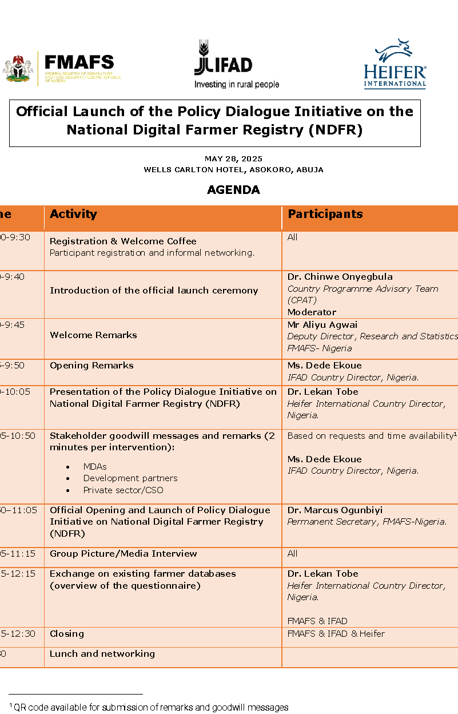

Annex 2 – Speech of the Permanent Secretary
OPENING REMARKS BY THE PERMANENT SECRETARY, FEDERAL MINISTRY OF AGRICULTURE AND FOOD SECURITY, DR. MARCUS O. OGUNBIYI AT THE POLICY DIALOGUE ON DIGITAL NATIONAL FARMERS' REGISTRY, HELD AT WELLS CARLTON HOTEL, ASOKORO, ABUJA ON WEDNESDAY, 28TH MAY 2025.
Protocols
1. It is my honour and great pleasure to welcome you all to this important Policy Dialogue on the Digital National Farmers' Registry, convened under the framework of the Federal Government of Nigeria–International Fund for Agricultural Development (FGN–IFAD) Digital Innovation Action Plan.
2. Let me begin by appreciating each and every one of you for honouring our invitation to be part of this crucial engagement. Your presence here today underscores the collective commitment we all share in advancing Nigeria's agricultural sector through the strategic deployment of digital tools, data, and inclusive policies.
3. I also want to specially express my sincere appreciation to IFAD and all our partners for your unwavering collaboration and steadfast commitment to strengthening Nigeria's agricultural systems. I would also like to acknowledge the presence of representatives from Ministries, Departments and Agencies (MDAs), the private sector, civil society, and—most importantly—the farming community. Your diverse perspectives and active participation are not only valued but essential to the success of this initiative.
4. As we are all aware, agriculture remains the backbone of Nigeria's economy — not just in terms of employment and livelihoods, but also in its potential to drive food security, industrial development, and export revenue. Yet, for far too long, our efforts to transform the sector have been hampered by a lack of reliable data, especially on the key actors — our farmers.
5. The Digital National Farmers' Registry is designed to address this gap. It is a transformative initiative that seeks to capture accurate, real-time, and geo-referenced data on farmers across the country — disaggregated by location, commodity, scale of production, gender, and age. This registry is not just a database, it is more than a database; it is a strategic tool for promoting inclusion, transparency, and measurable impact.

6. It is the foundation for evidence-based planning, targeted intervention, inclusive policymaking, and accountability in the agricultural ecosystem. It allows us to identify and reach real farmers with the right support, eliminate inefficiencies, and ensure that resources are aligned with national priorities. A reliable and up-to-date Farmers' Registry is therefore fundamental to effective planning, precise targeting, and efficient delivery of agricultural interventions.
7. With a credible farmers' registry, we can ensure that inputs reach the intended beneficiaries; that support programmes are tailored to the actual needs of our farmers, and that government interventions yield the desired impact. Moreover, it will empower financial institutions, agribusinesses, insurers, and other stakeholders to engage with our farmers with clarity, confidence, and precision.
8. In recognition of this, the Federal Ministry of Agriculture and Food Security has taken decisive steps to transform our approach to farmer data management. Chief among these is our strategic partnership with the National Identity Management Commission (NIMC) to implement a far-reaching Farmer Registration and Database Project. At the heart of this initiative is the integration of the National Identification Number (NIN), which ensures that every Nigerian farmer is uniquely identified and seamlessly integrated into a national agricultural system.
9. Moreover, the registration process involves geo-tagging farmers to their farmlands, a feature that enhances traceability, planning, and monitoring. This bold move marks a major milestone in our efforts to improve transparency, eliminate ghost beneficiaries, and deliver effective government-to-people (G2P) services.
10. In practical terms, we are digitising and harmonising farmer data across all 36 states and the Federal Capital Territory. By linking farmers to a government-to-people (G2P) Card, we enable direct access to inputs, interventions, extension services, and financial inclusion. Importantly, we see digital identity not just as a technological solution, but as a catalyst for empowerment—one that opens doors to credit, insurance, climate-smart technologies, and market opportunities.
11. Let me also state that as part of the digital farmer friendly programme of the Ministry, The National Electronic Extension Platform (NEEP) has just been developed and launched in March 2025. It is a digital initiative aimed at improving agricultural service delivery, boosting productivity, and strengthening connections between research institutions and farmers. This platform will also be interoperable with the Farmer Registry platform and make access to quality extension services very easy and seamless for all stakeholders in the agricultural sector.

12. To complement this effort, the Ministry is also developing the National Agricultural Data Management and Information System (NADM IS). This centralised platform is designed to harmonise and integrate agricultural data across all departments, programmes, and projects. Once operational, NADMIS will serve as a unified, interoperable system to improve planning, coordination, and responsiveness across the agricultural sector.

13. Indeed, this database is not merely a list of names and numbers. It is a dynamic instrument for inclusive agricultural governance. It will enable us to design and implement targeted interventions for smallholders, women, youth, and other vulnerable groups, ensuring that no one is left behind in our pursuit of sustainable development.

14. Therefore, today's policy dialogue is both timely and strategic. It provides us with a valuable opportunity to reflect on our progress, identify policy and operational gaps, and build consensus around the institutional frameworks required to sustain and scale these initiatives. Our collective efforts here will directly contribute to achieving the Renewed Hope Agenda of His Excellency, President Bola Ahmed Tinubu, GCFR.

15. Achieving this ambitious vision requires more than just good intentions or even government effort alone — it demands robust, strategic, and sustained collaboration with all relevant stakeholders.

16. In this regard, I must specially acknowledge the International Fund for Agricultural Development (IFAD) and other development partners for their continued support in strengthening agricultural systems in Nigeria. IFAD's longstanding commitment to smallholder farmers, its technical expertise, and its strategic investments in rural development have been instrumental in bridging capacity gaps, enhancing digital inclusion, and strengthening the resilience of our food systems.

17. The implementation and sustainability of the Digital Farmers' Registry will benefit immensely from such partnerships — not only in terms of funding, but also in technical design, knowledge transfer, institutional capacity-building, and inclusive governance mechanisms. Our collaboration with IFAD and similar institutions ensures that the registry is not just a database, but a living tool aligned with global best practices and tailored to local. realities.
18. We must also deepen our collaboration with local governments, farmer cooperatives, financial institutions, telecom providers, and civil society actors to ensure last-mile data collection and the full integration of rural farmers into the national agricultural landscape.
19. Ladies and gentlemen, this is a defining moment for the future of agriculture in Nigeria. With strong collaboration, credible data, and a shared vision, we can build an agricultural system that is efficient, equitable, and transformative.
20. Once again, I thank you for your presence and contributions. Let us work together to make the Digital National Farmers' Registry a cornerstone of our national food security architecture.
21. On this note, I wish to once again thank you all for your presence and wish us all fruitful and impactful deliberations.
22. Thank you, and may God bless the Federal Republic of Nigeria.

Annex 3 – Presentation Slides by Heifer Nigeria

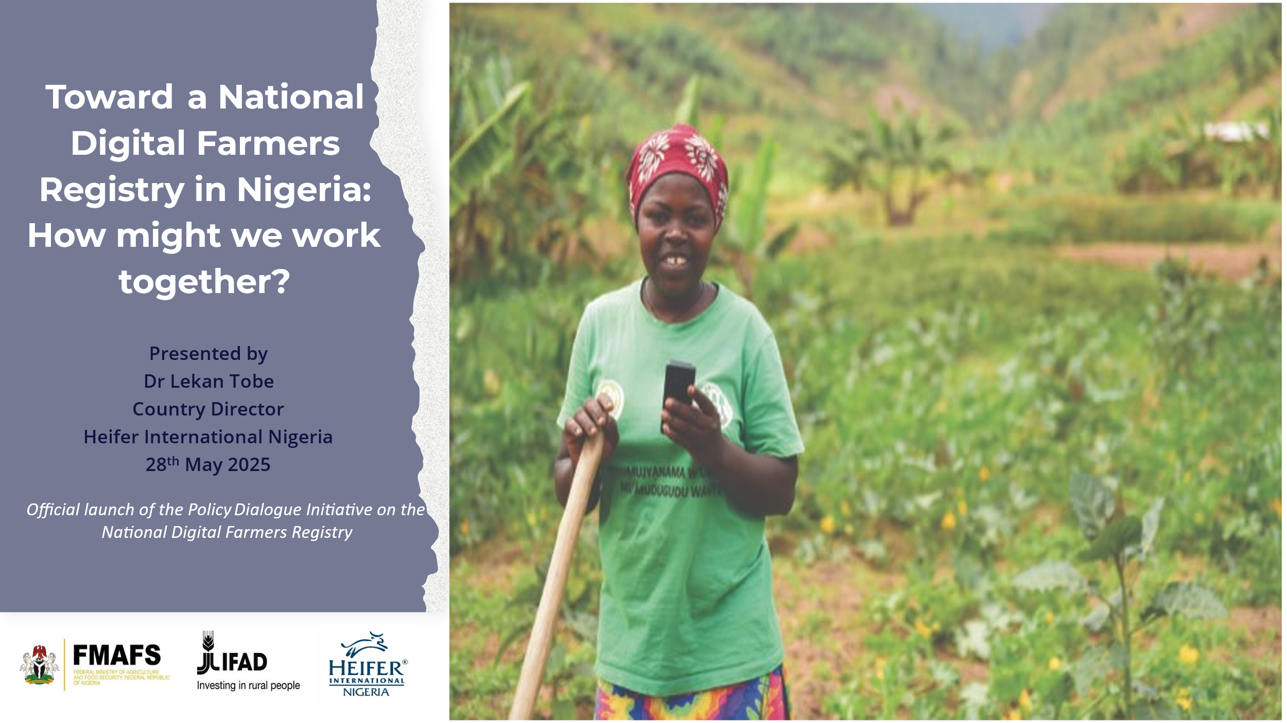
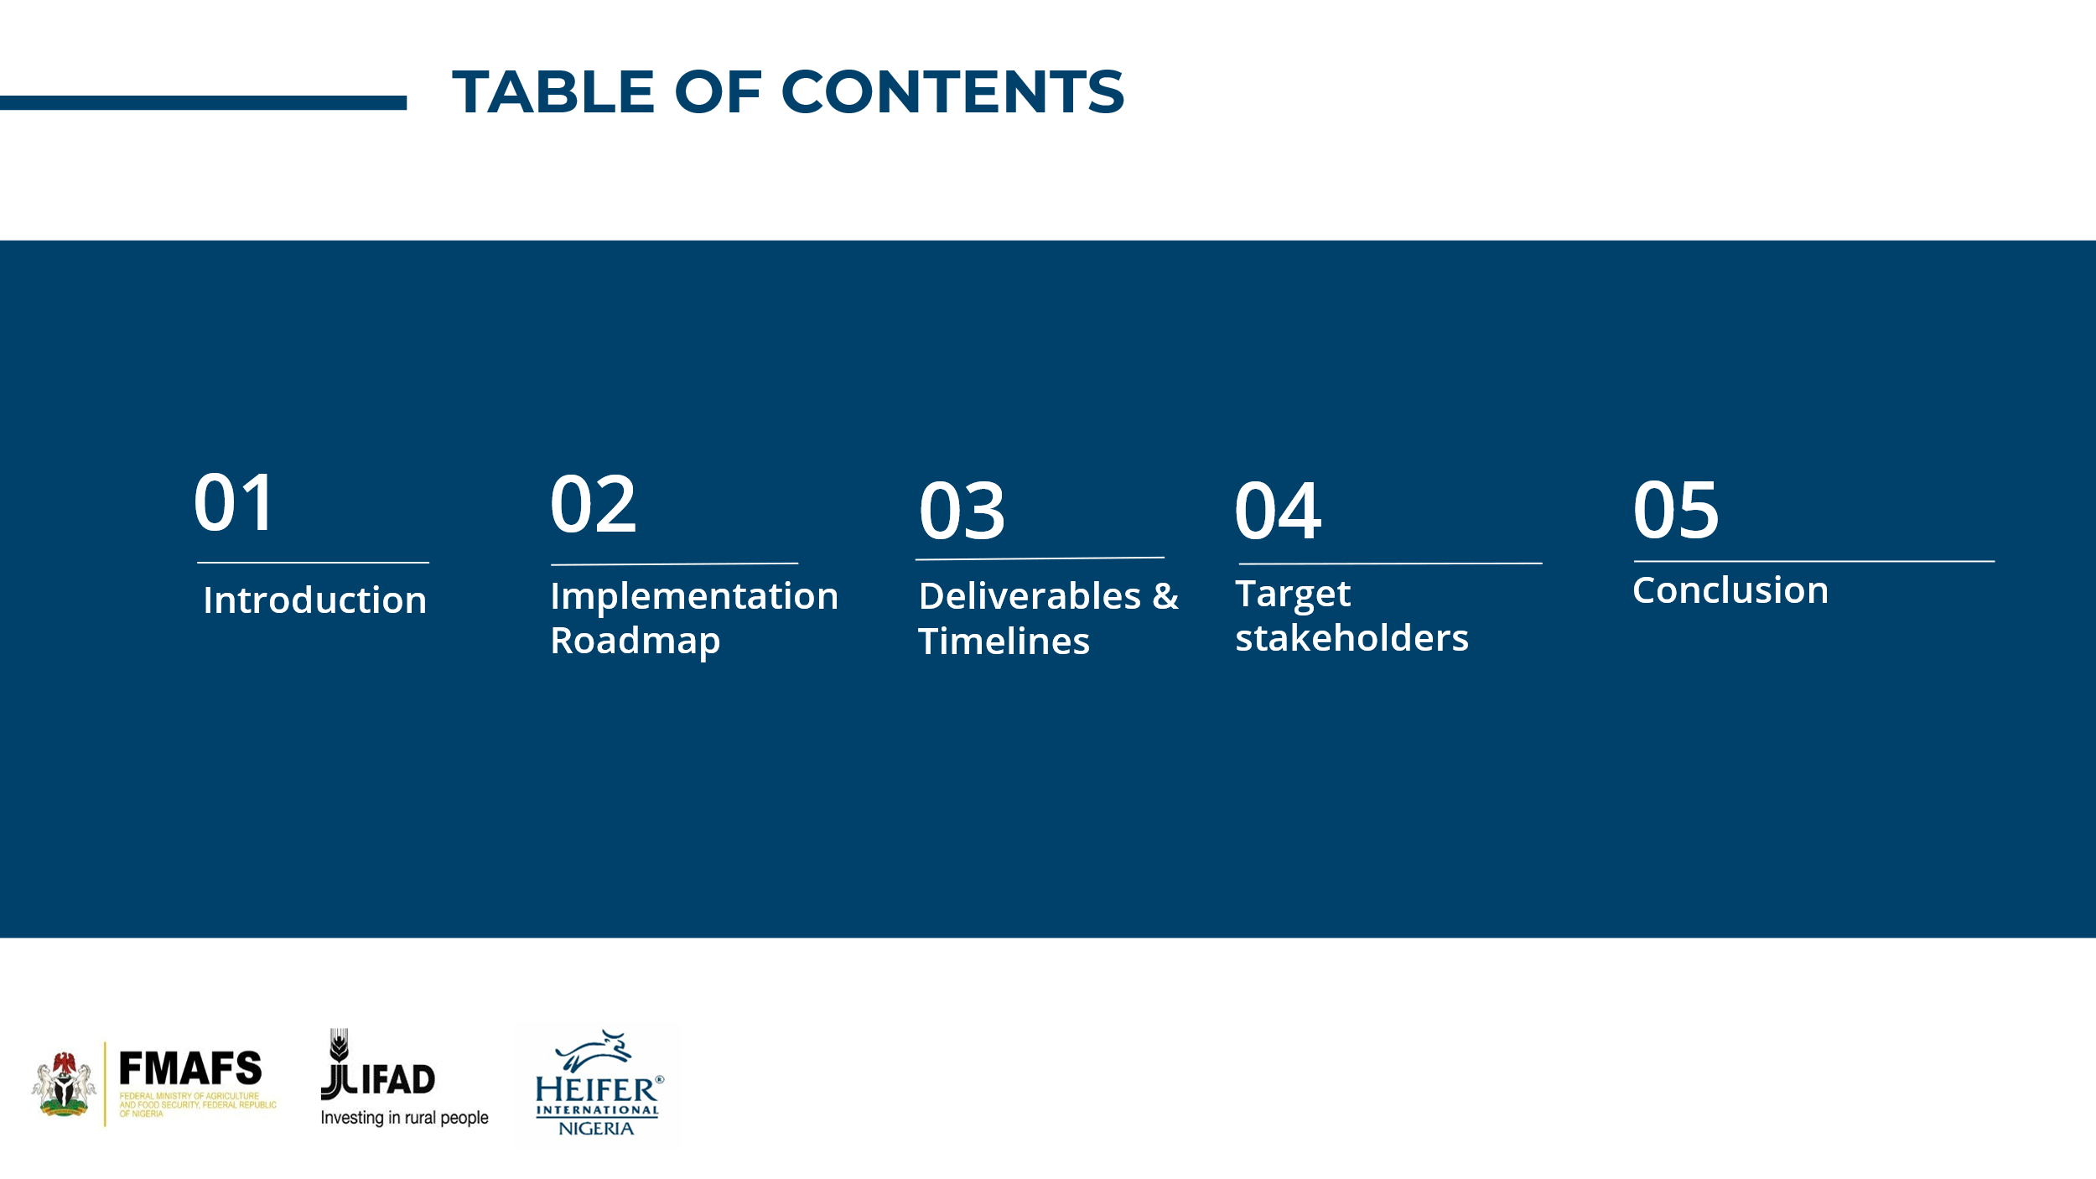
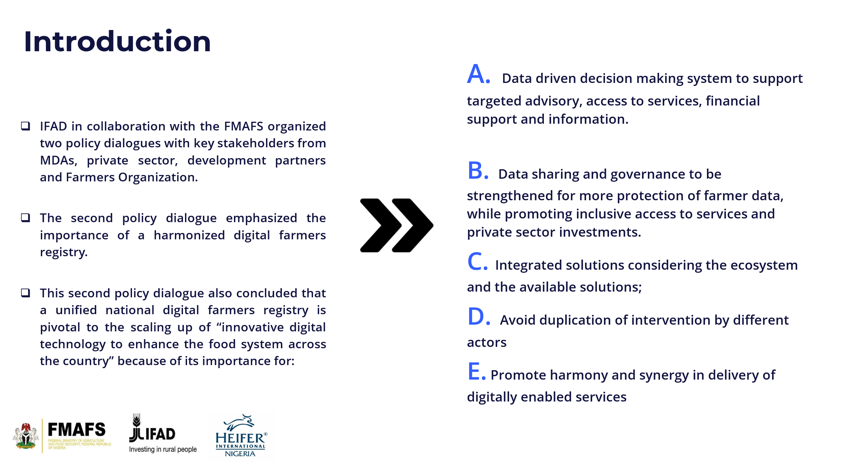
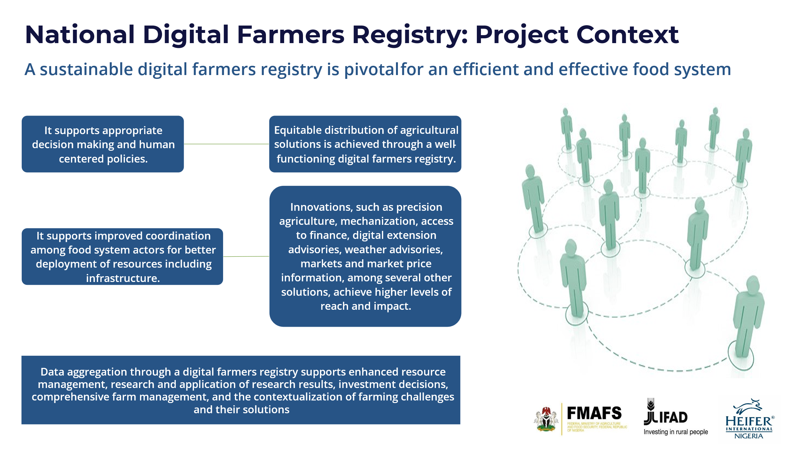
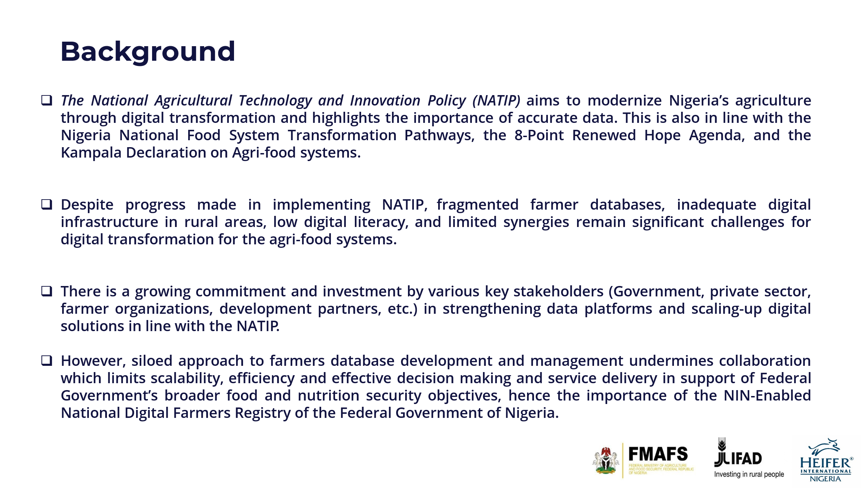
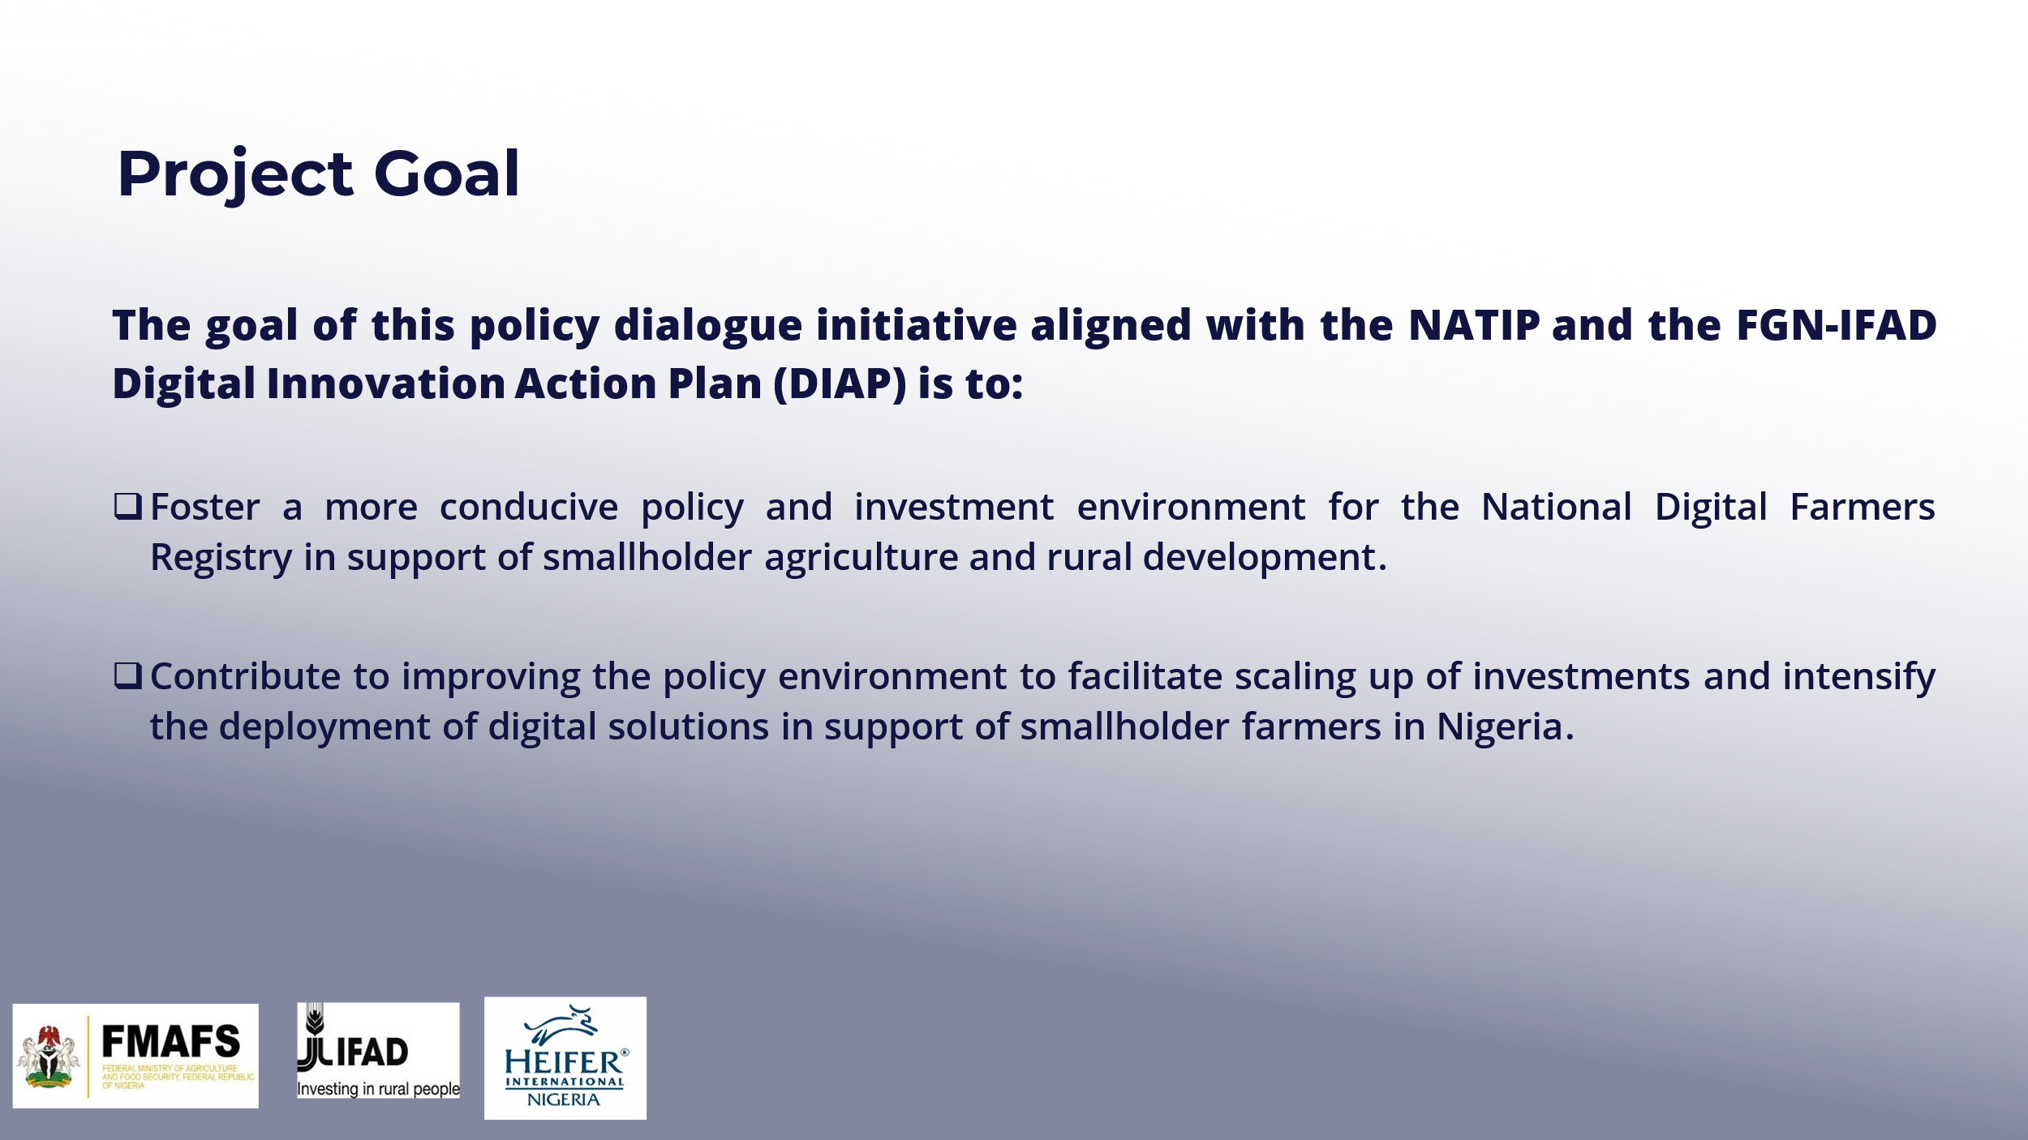

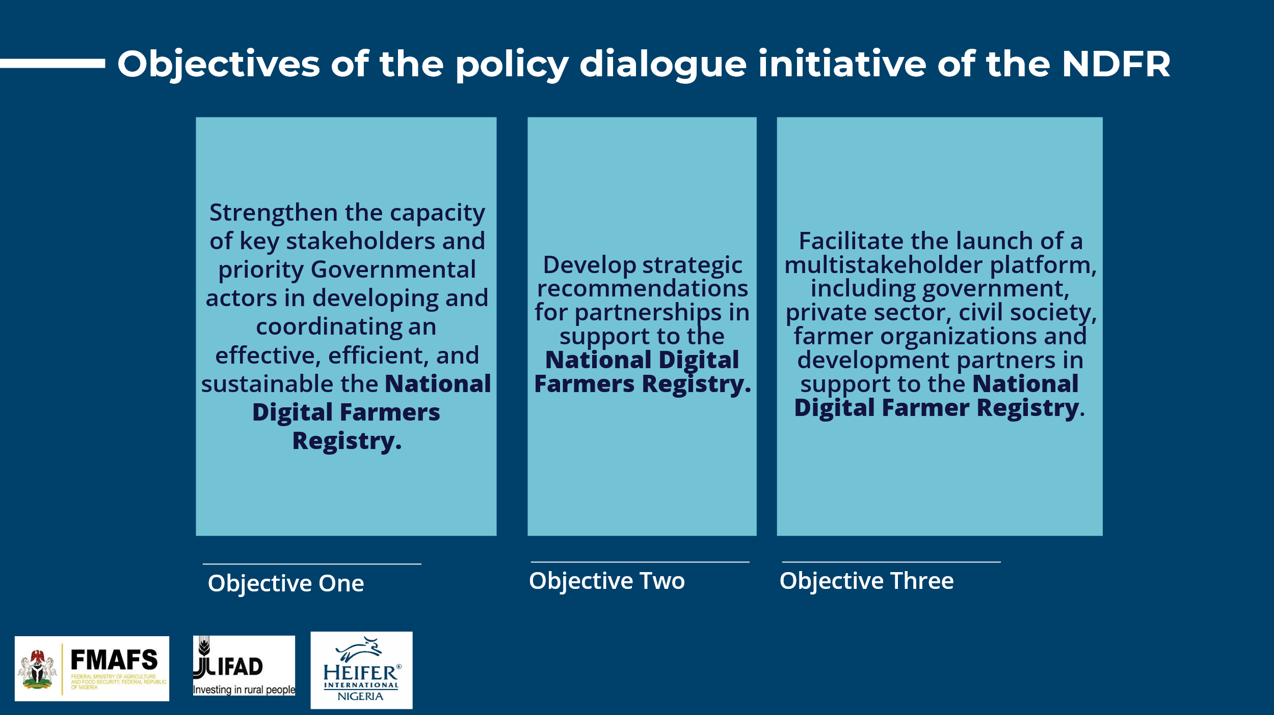

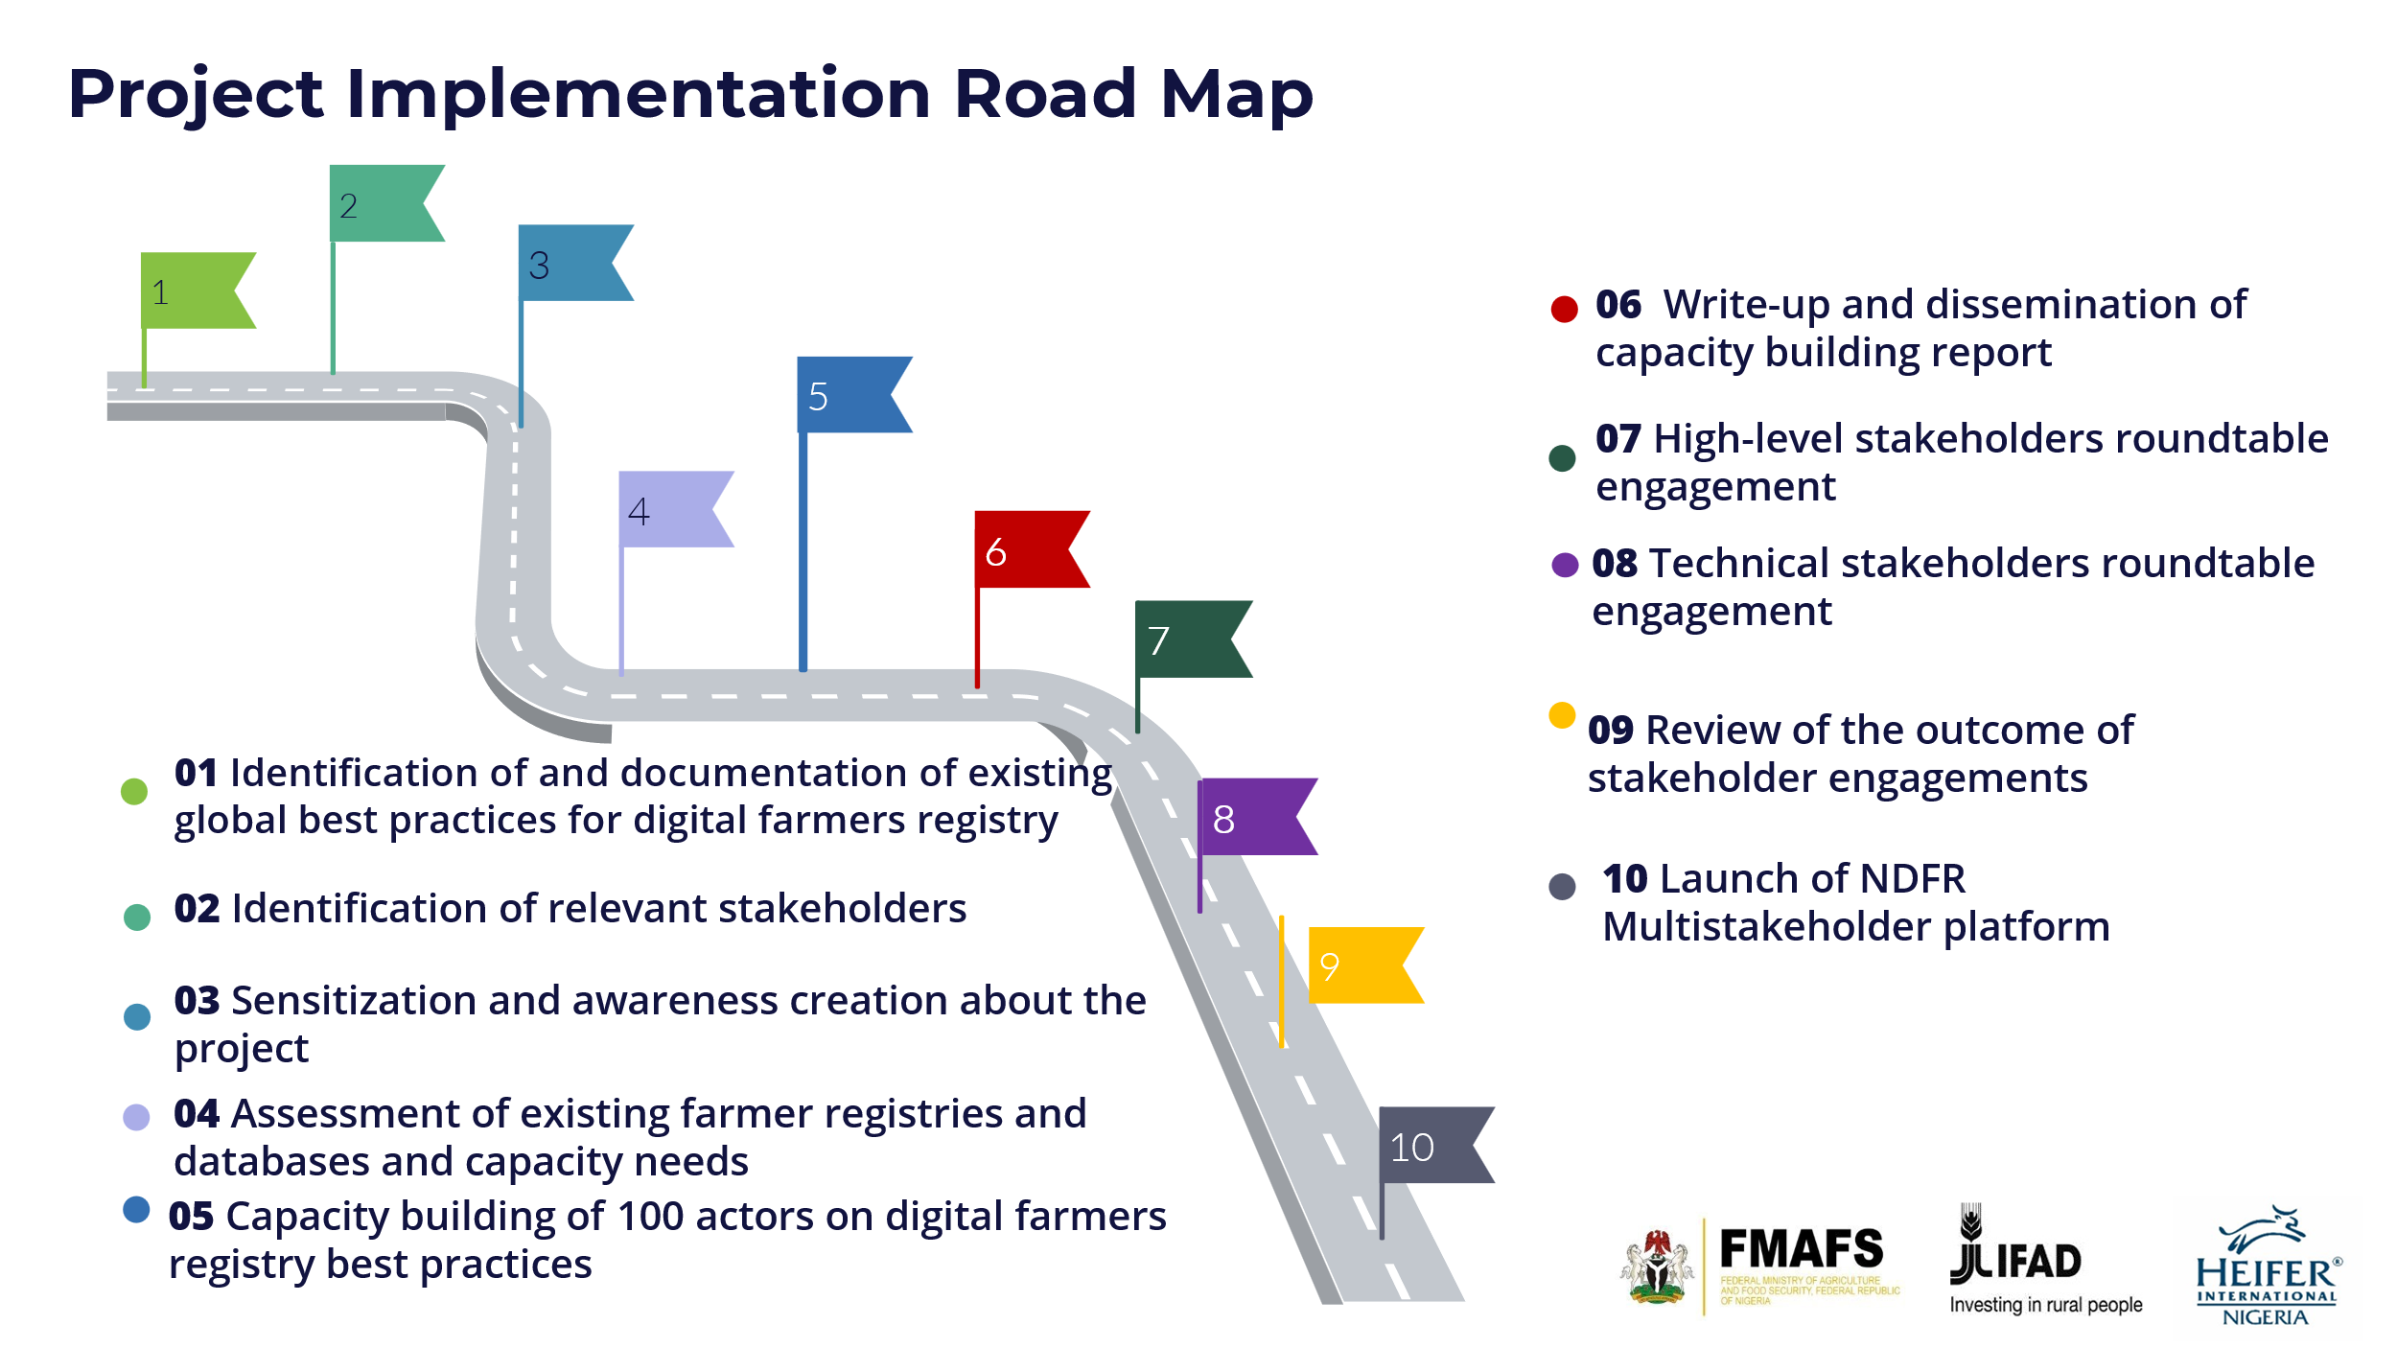

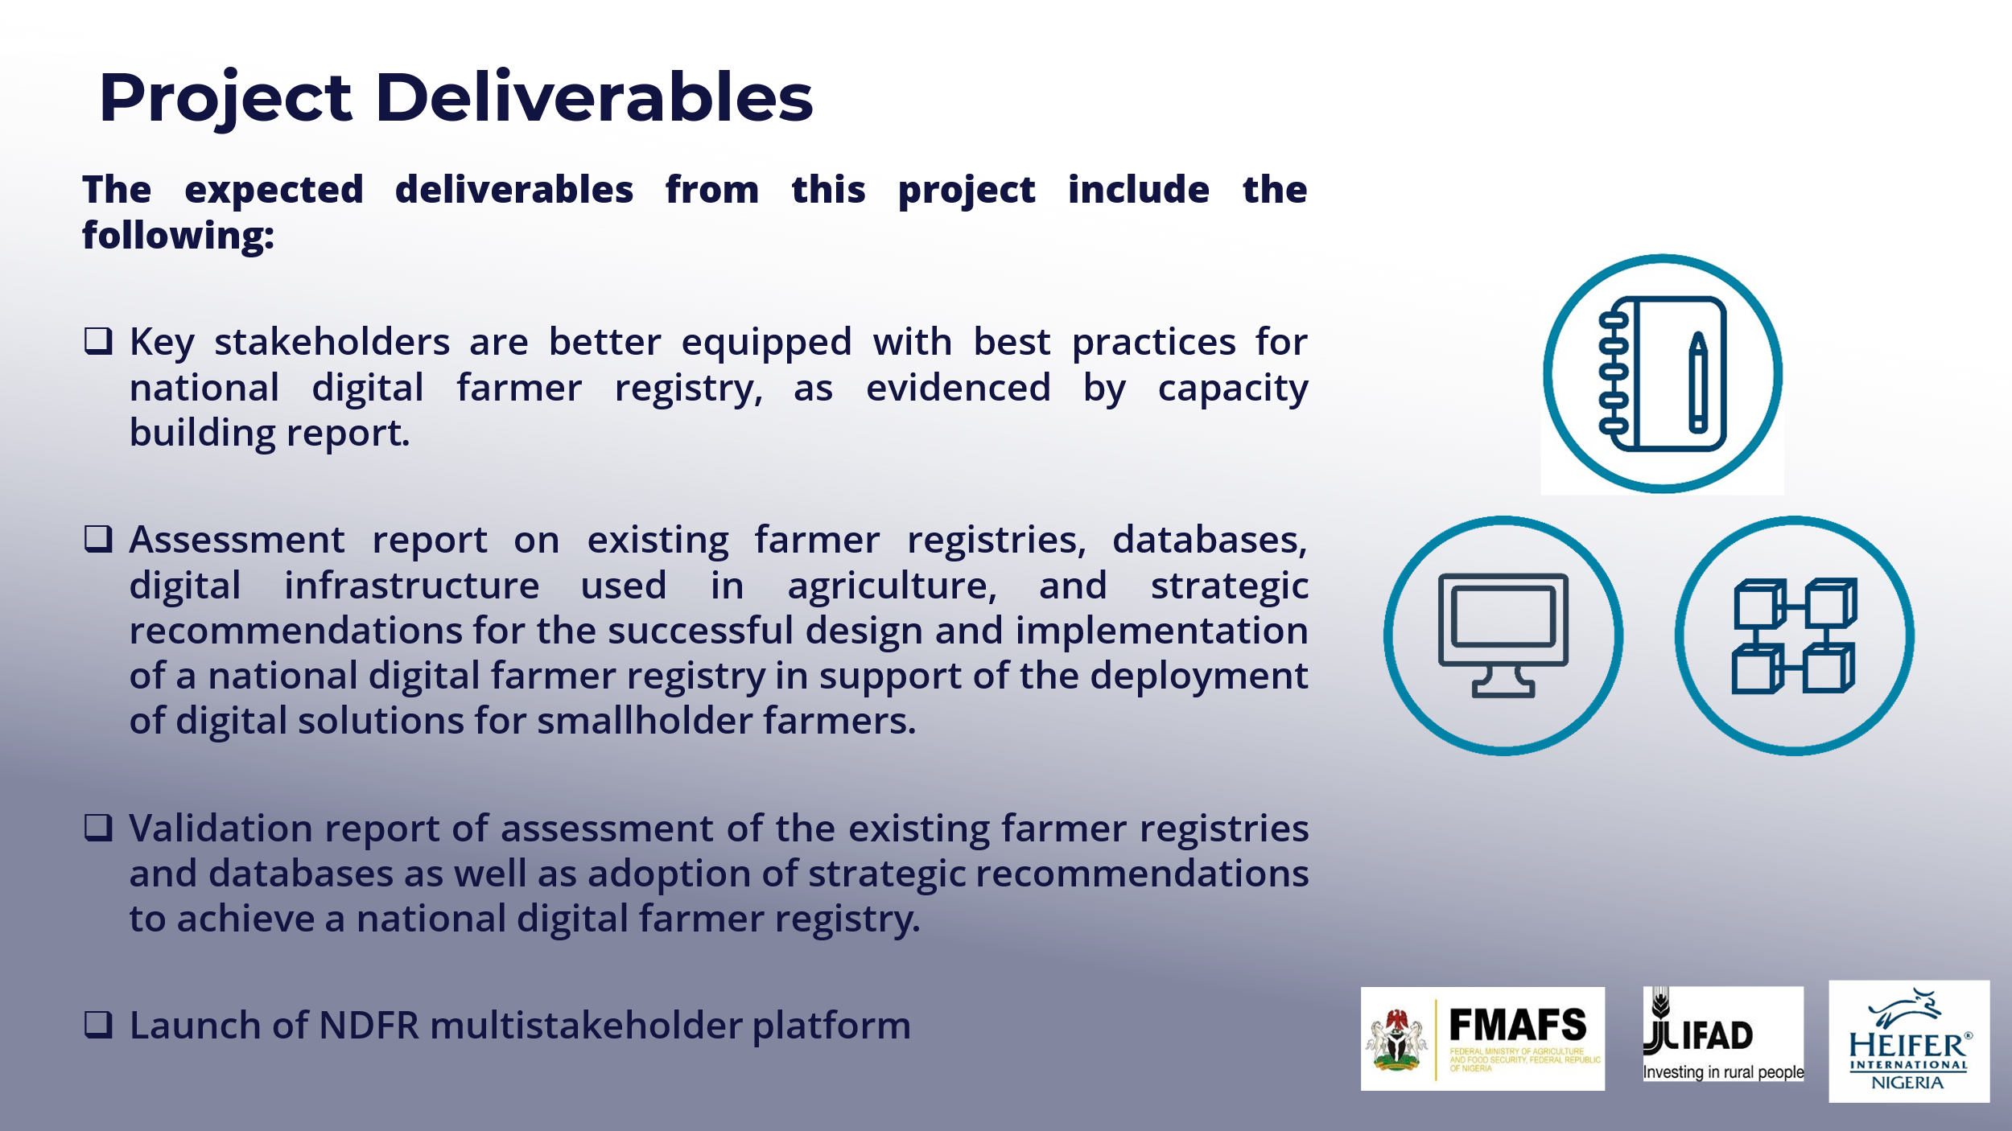

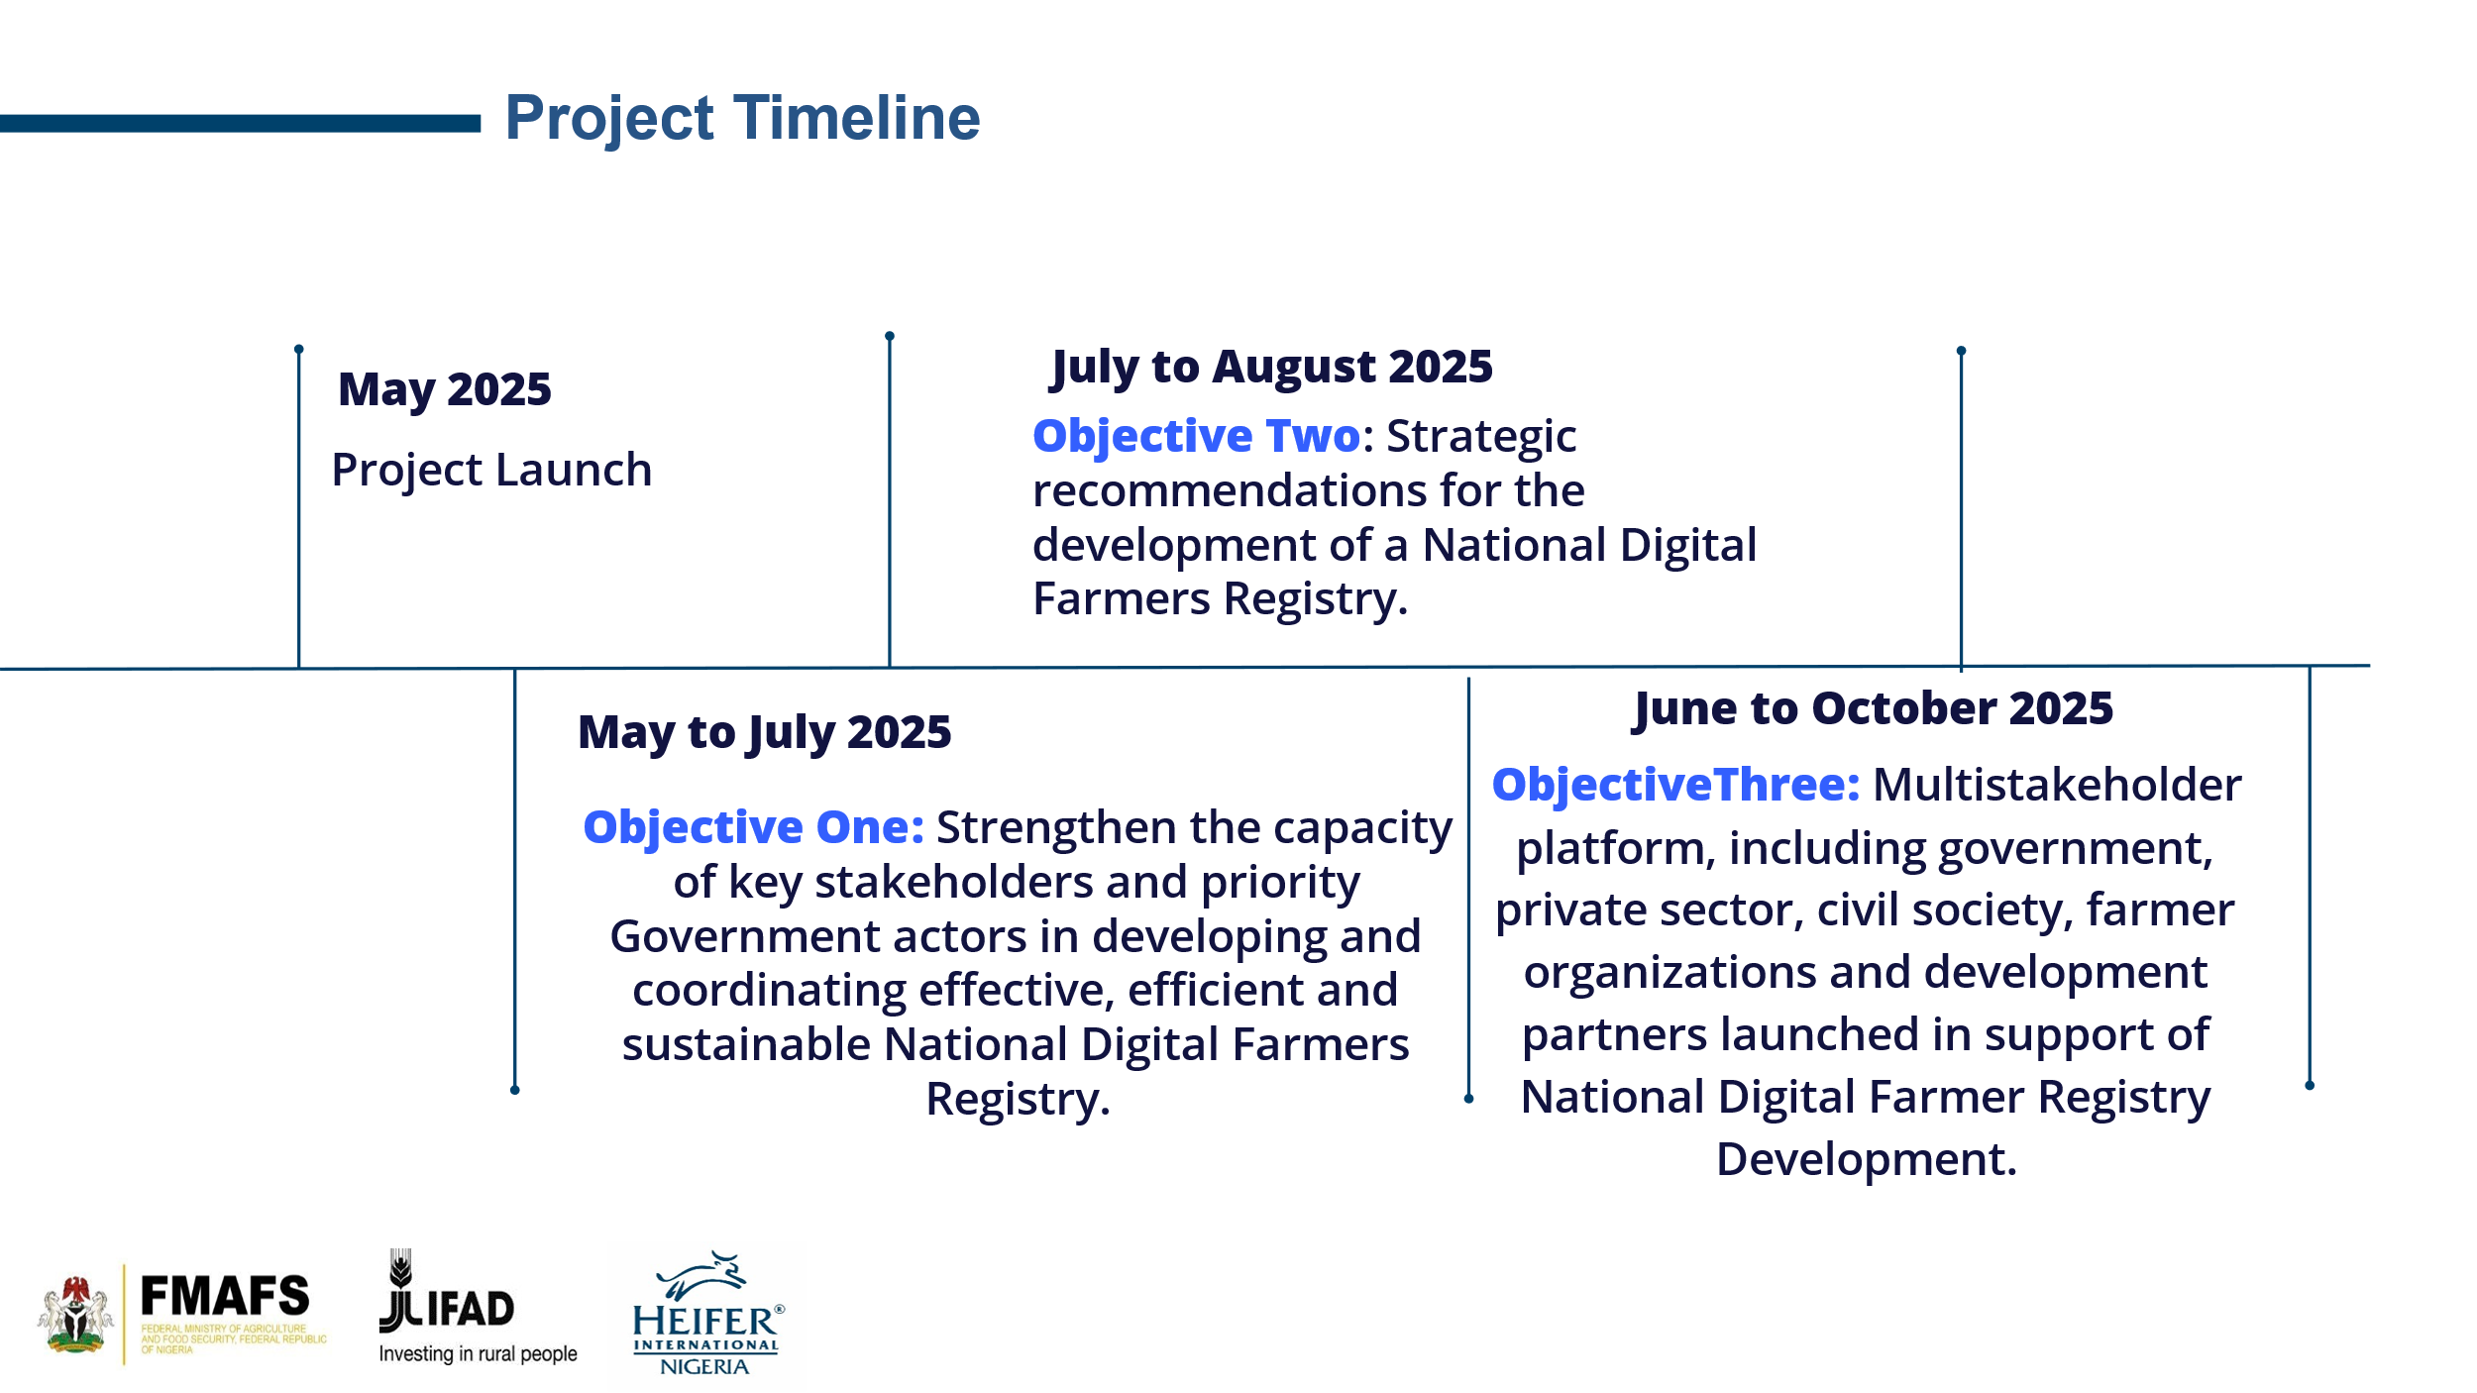

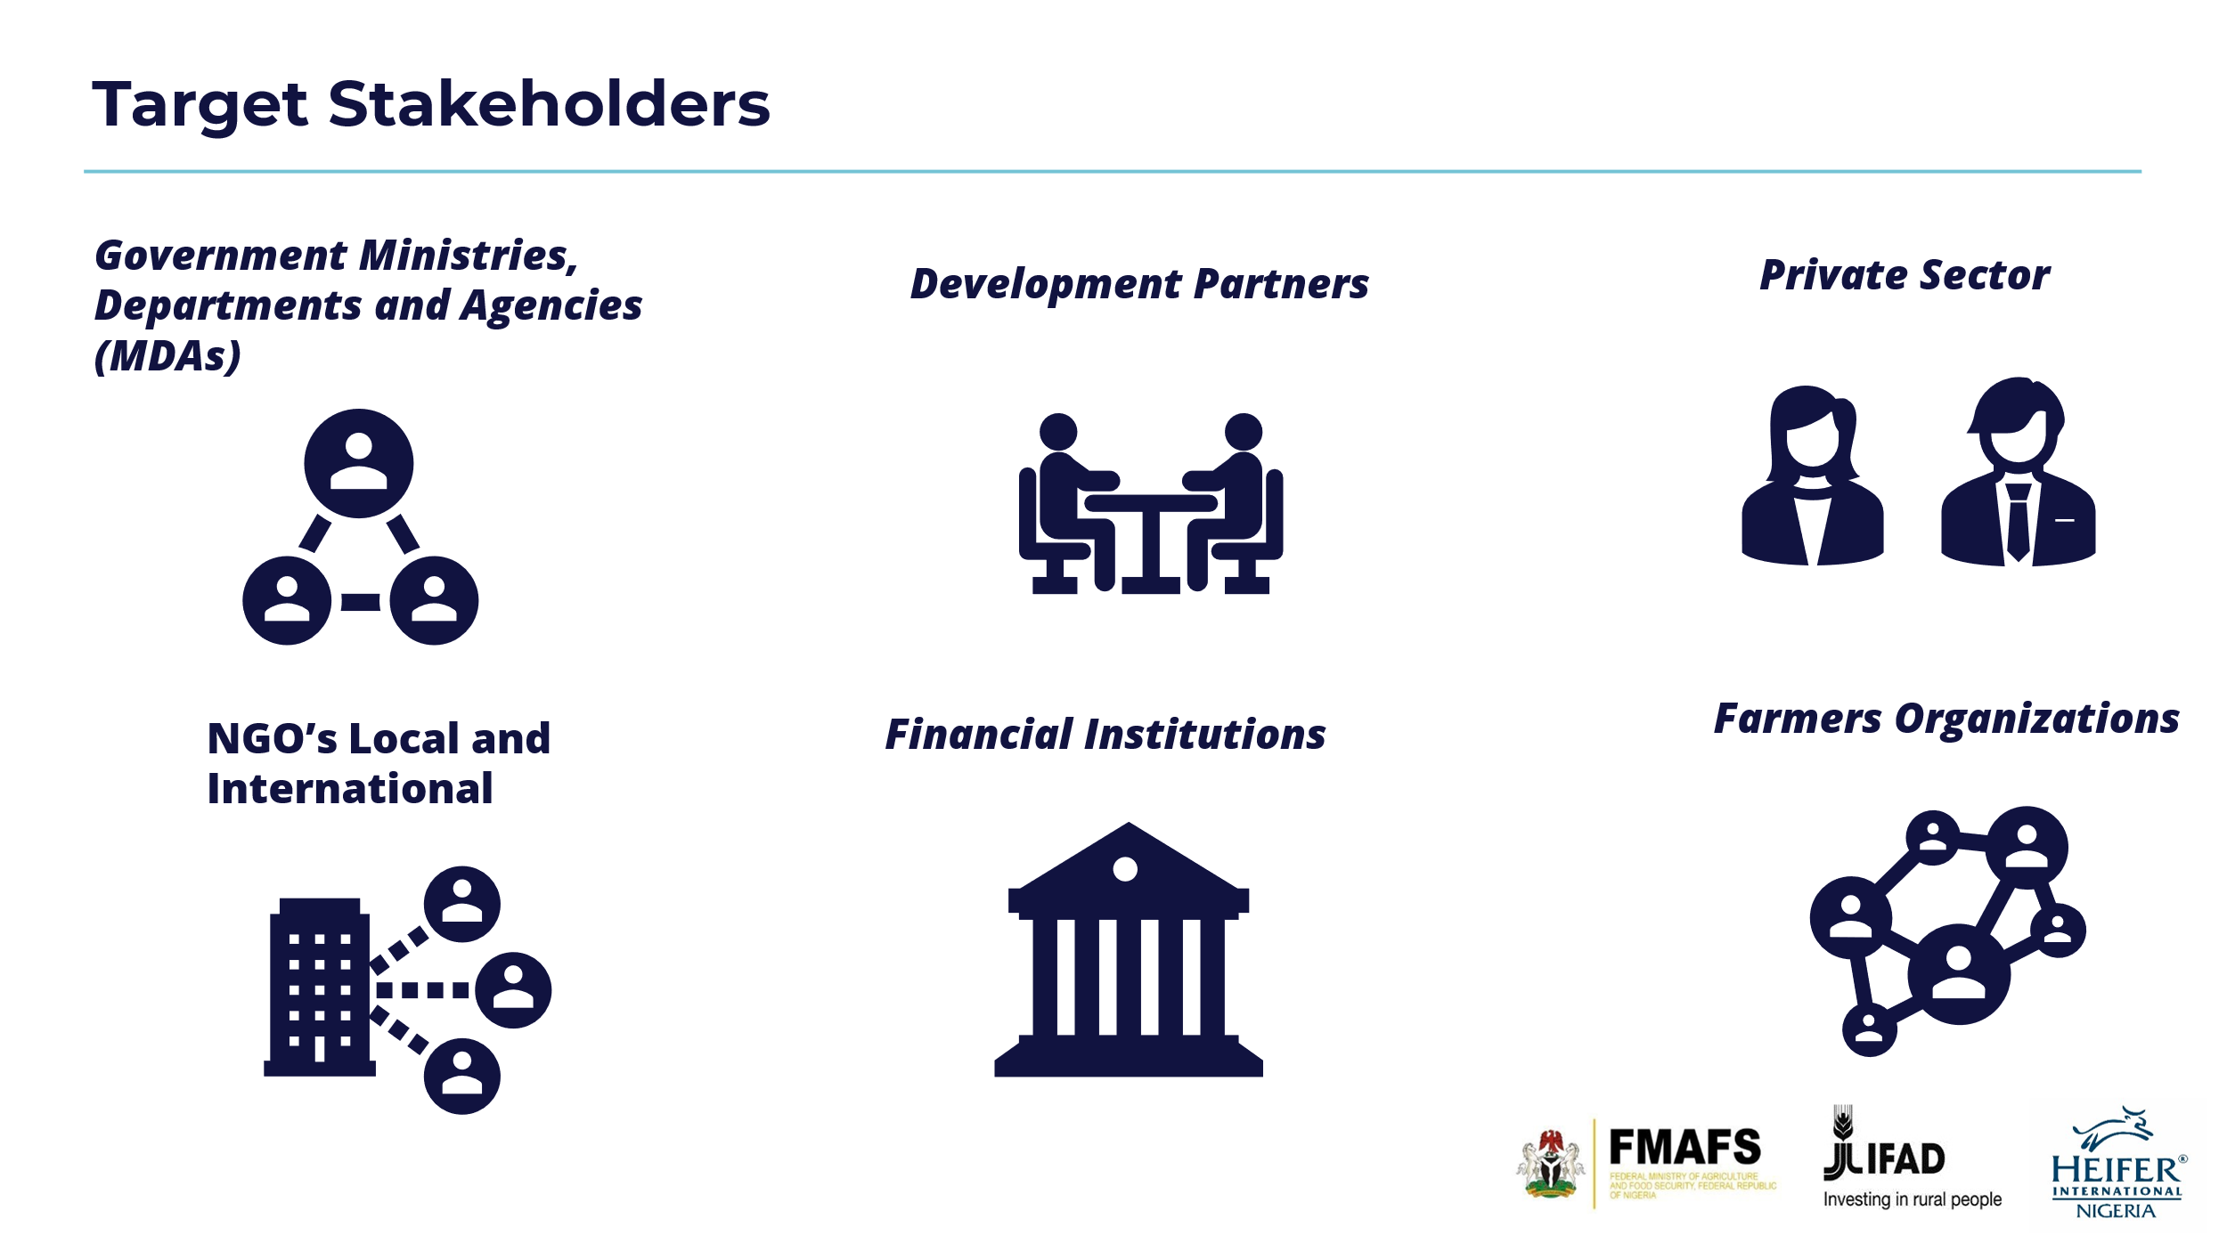

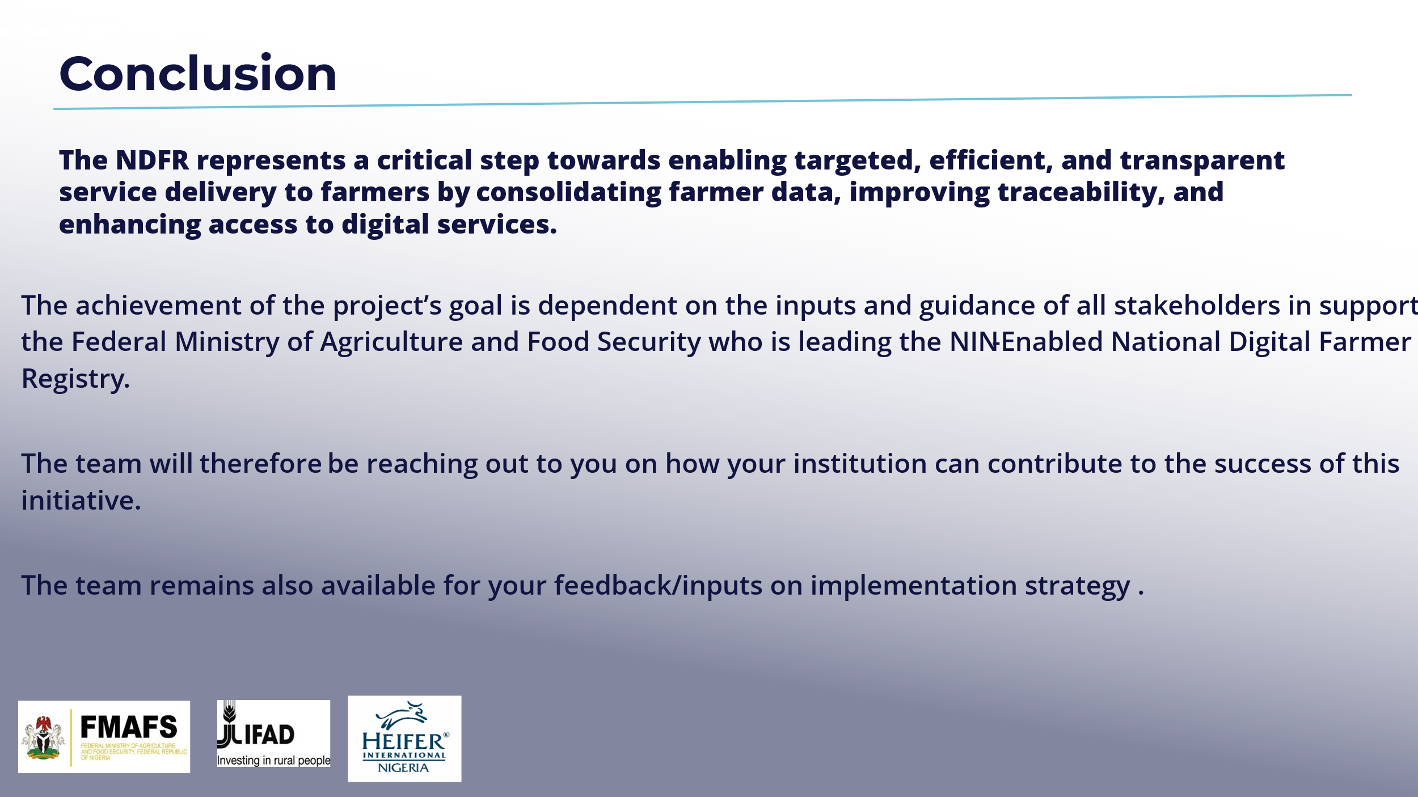

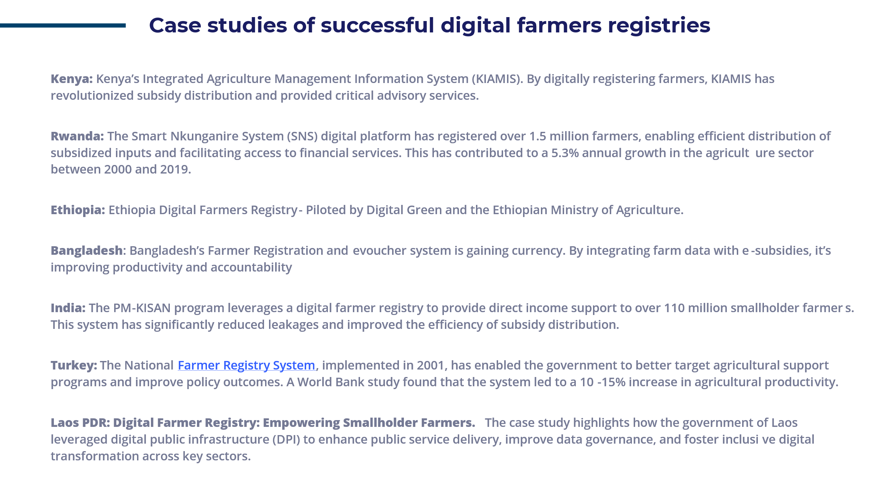
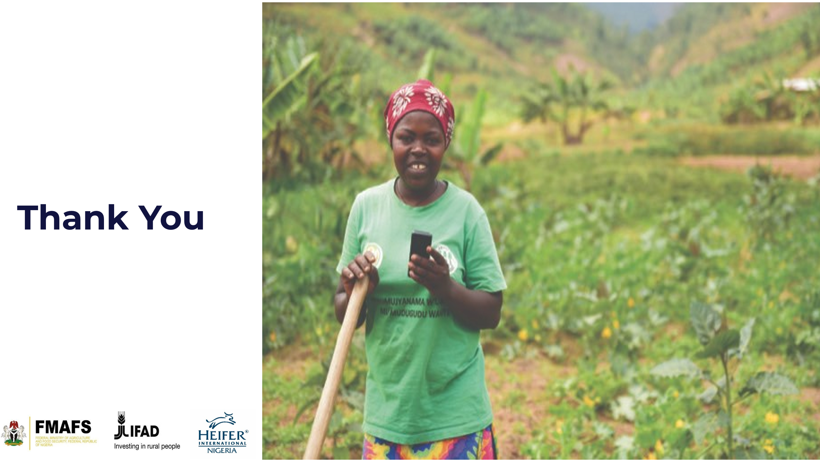

Annex 4 – Workshop Documentation QR-Codes
WORKSHOP QR-CODES

QR Code for Rapid Overview of Digital Farmers Databases in Nigeria

QR Code for FGN/IFAD ICT4Ag Background Documentation
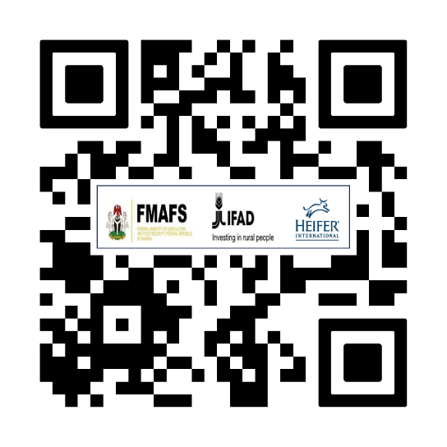
QR Code for Providing Feedback

Annex 5 - Questionnaire Responses

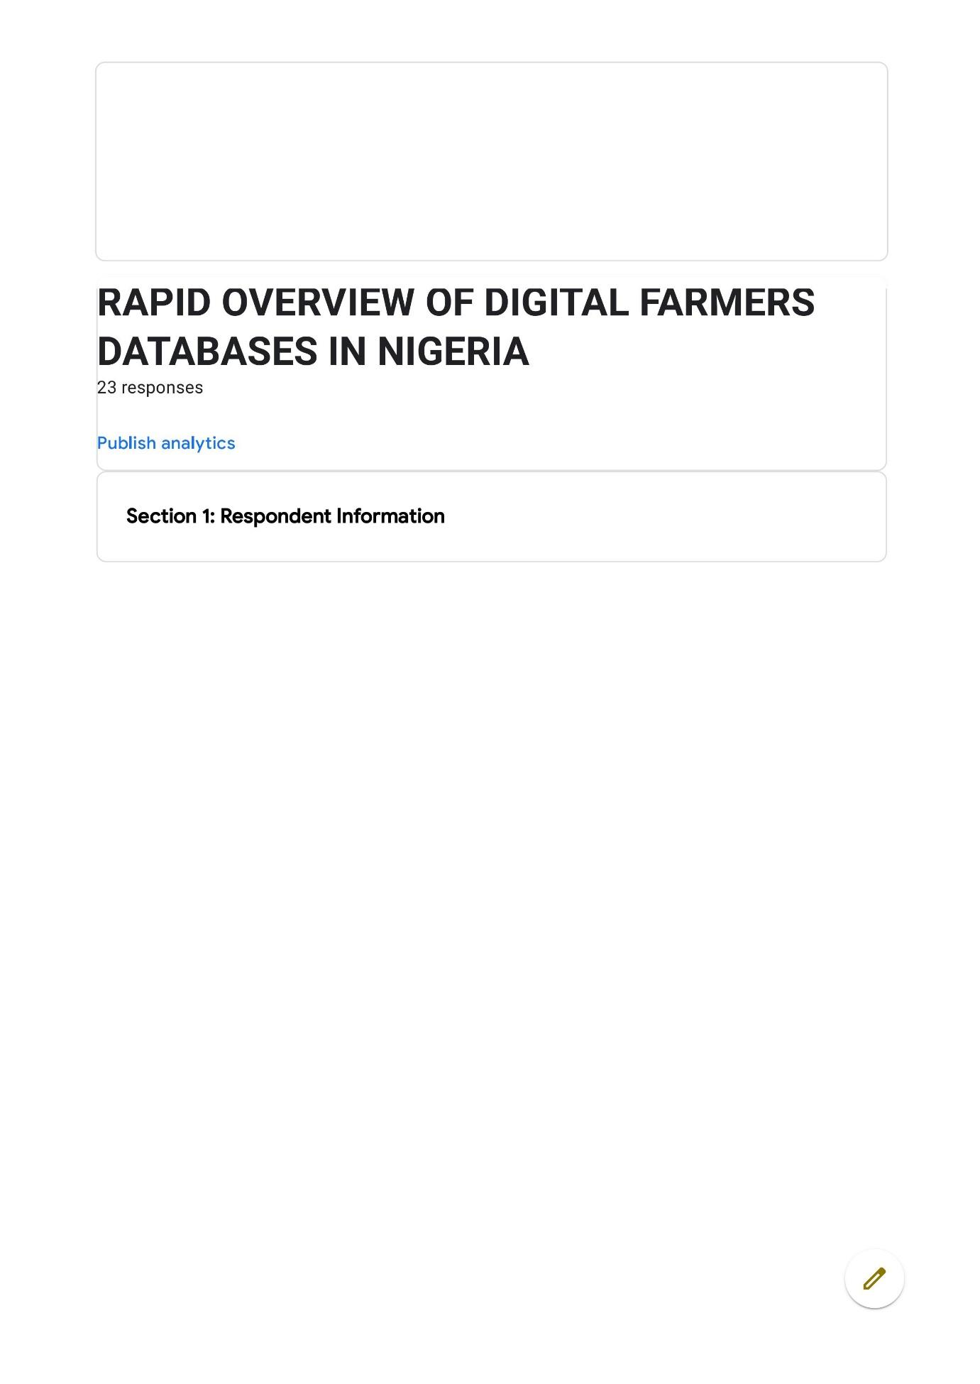
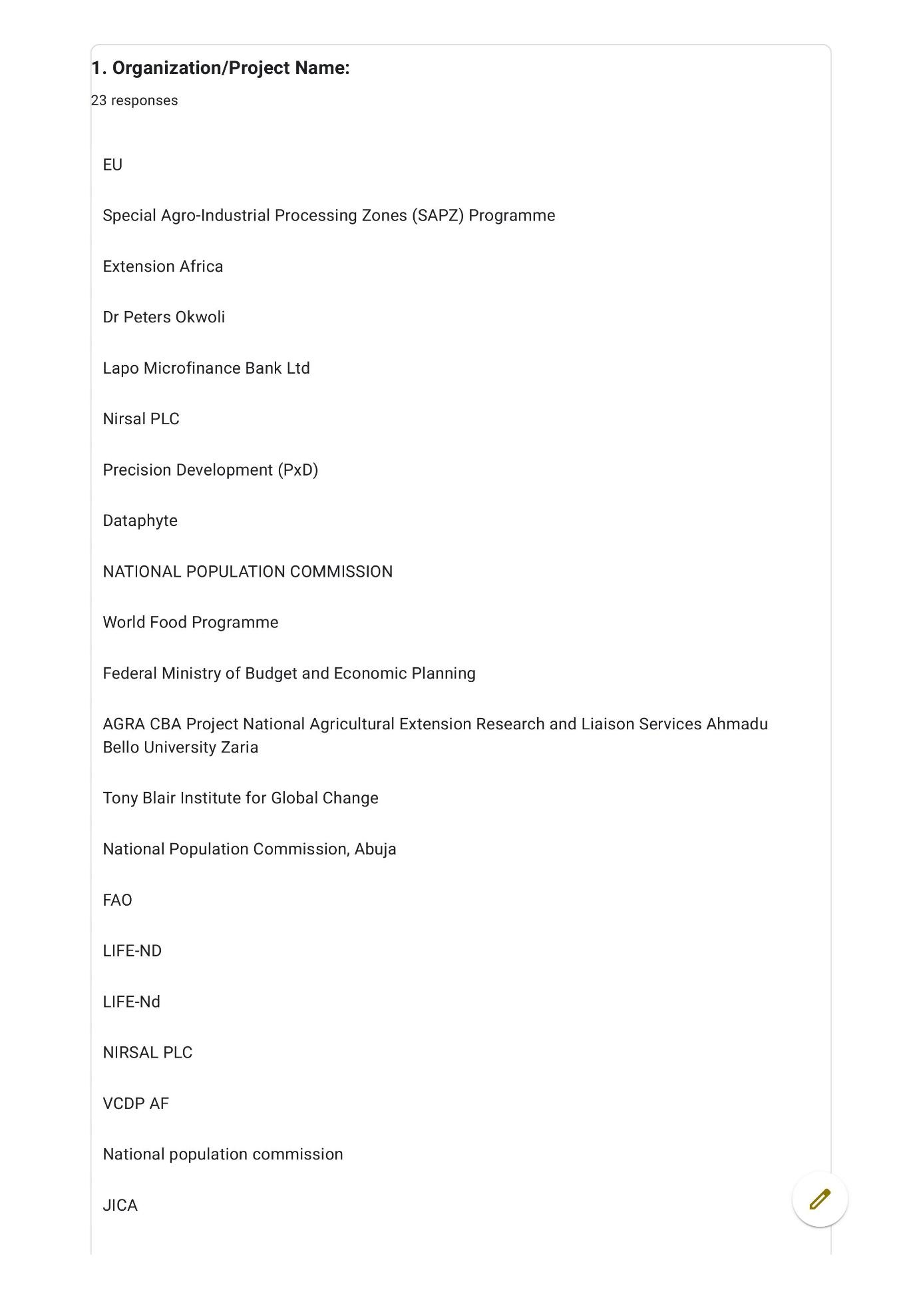
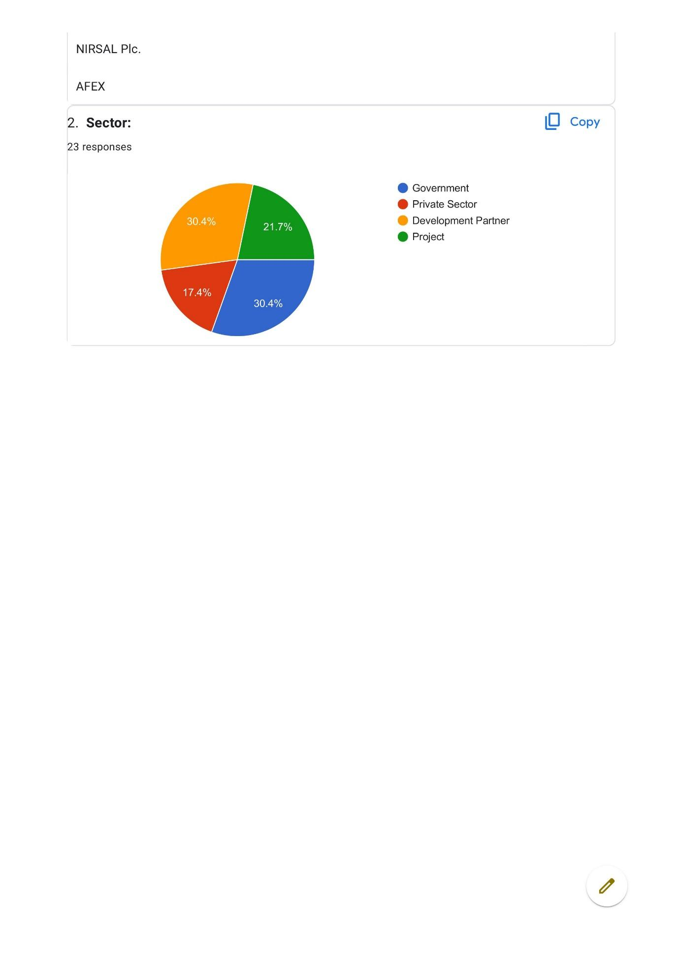
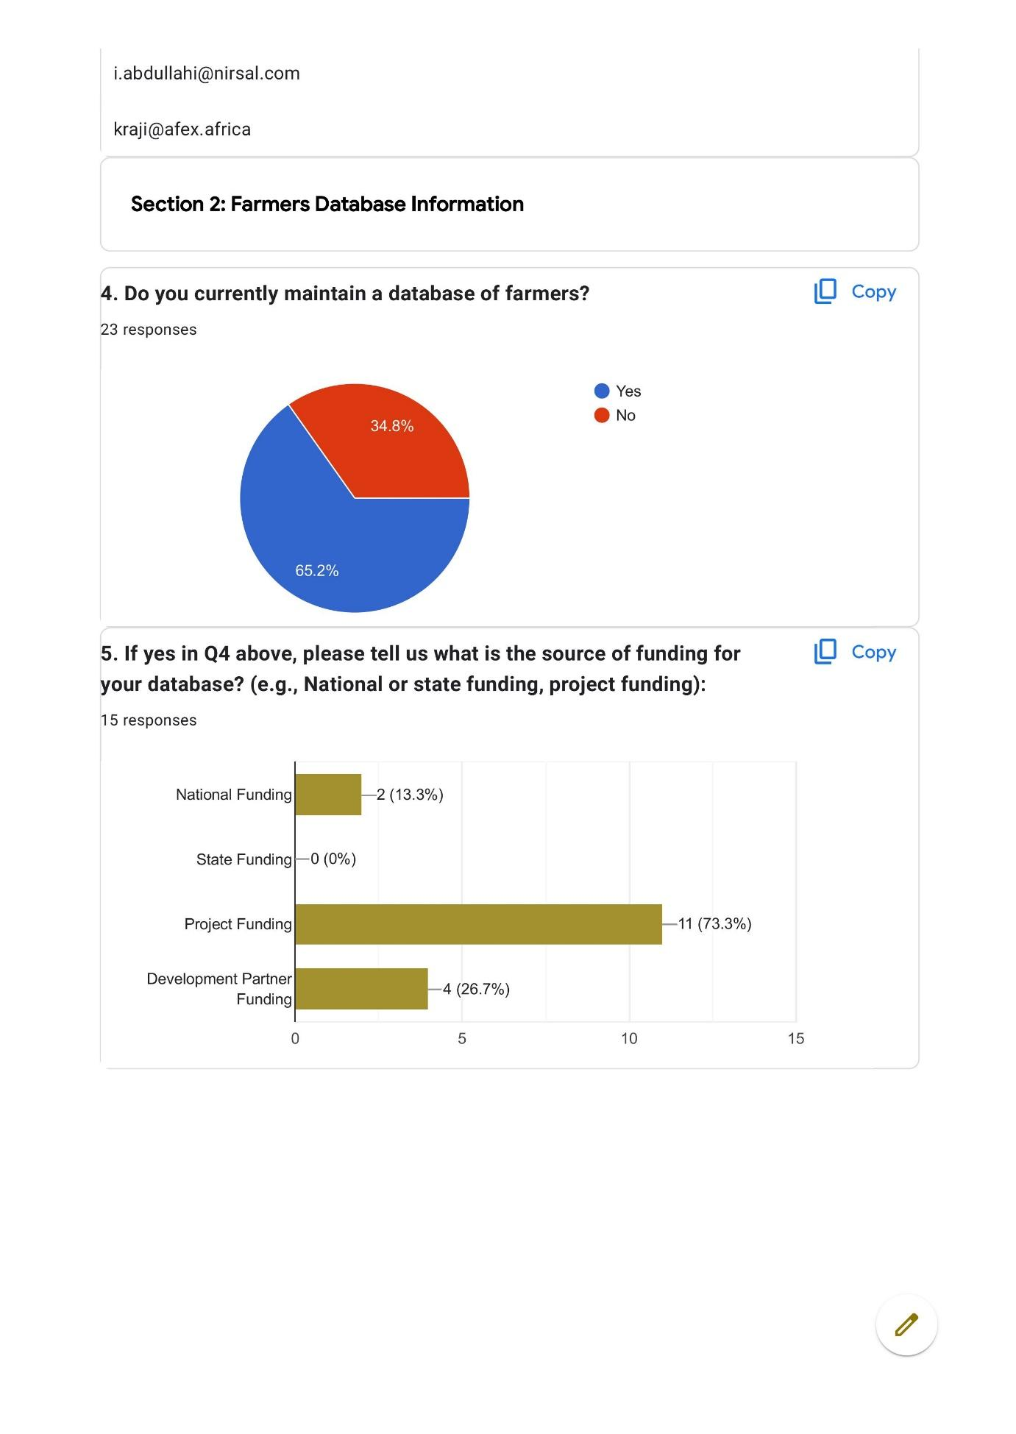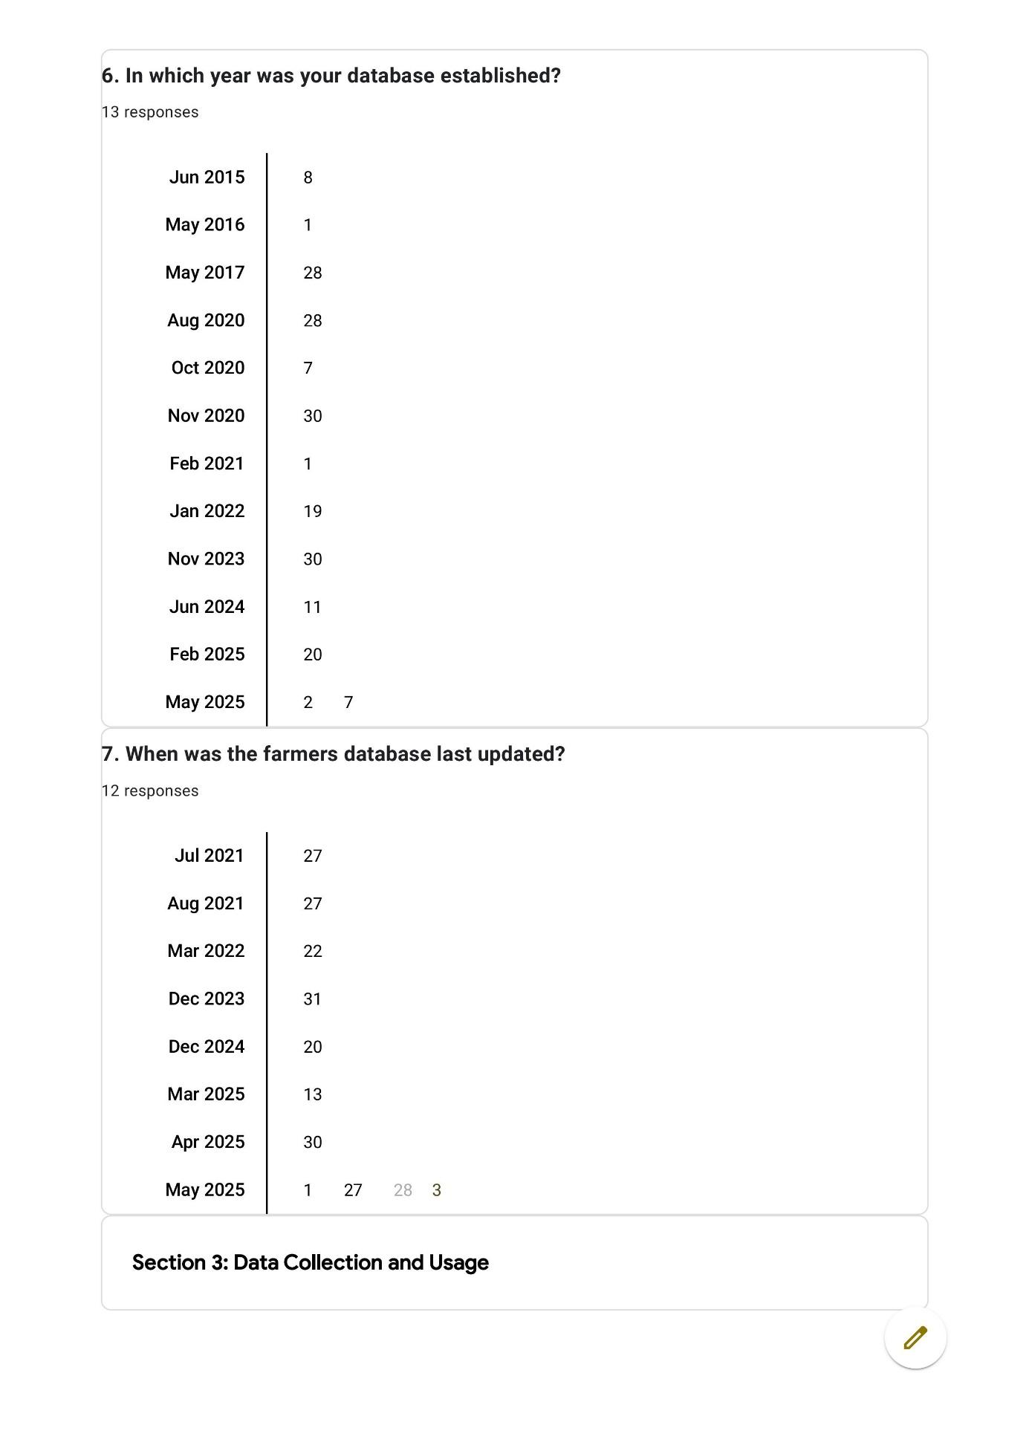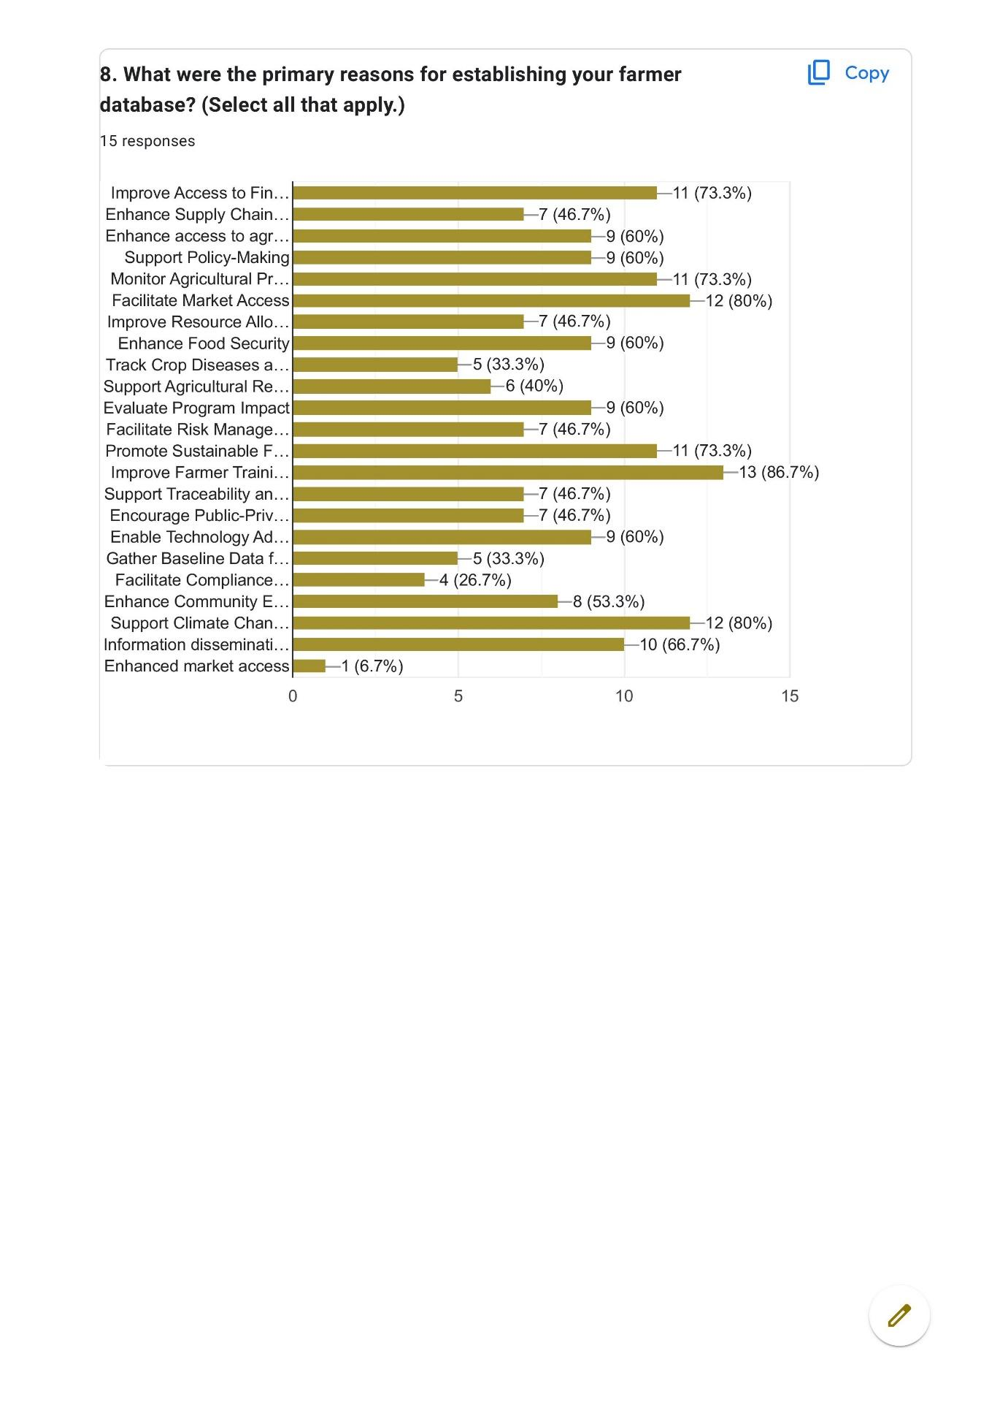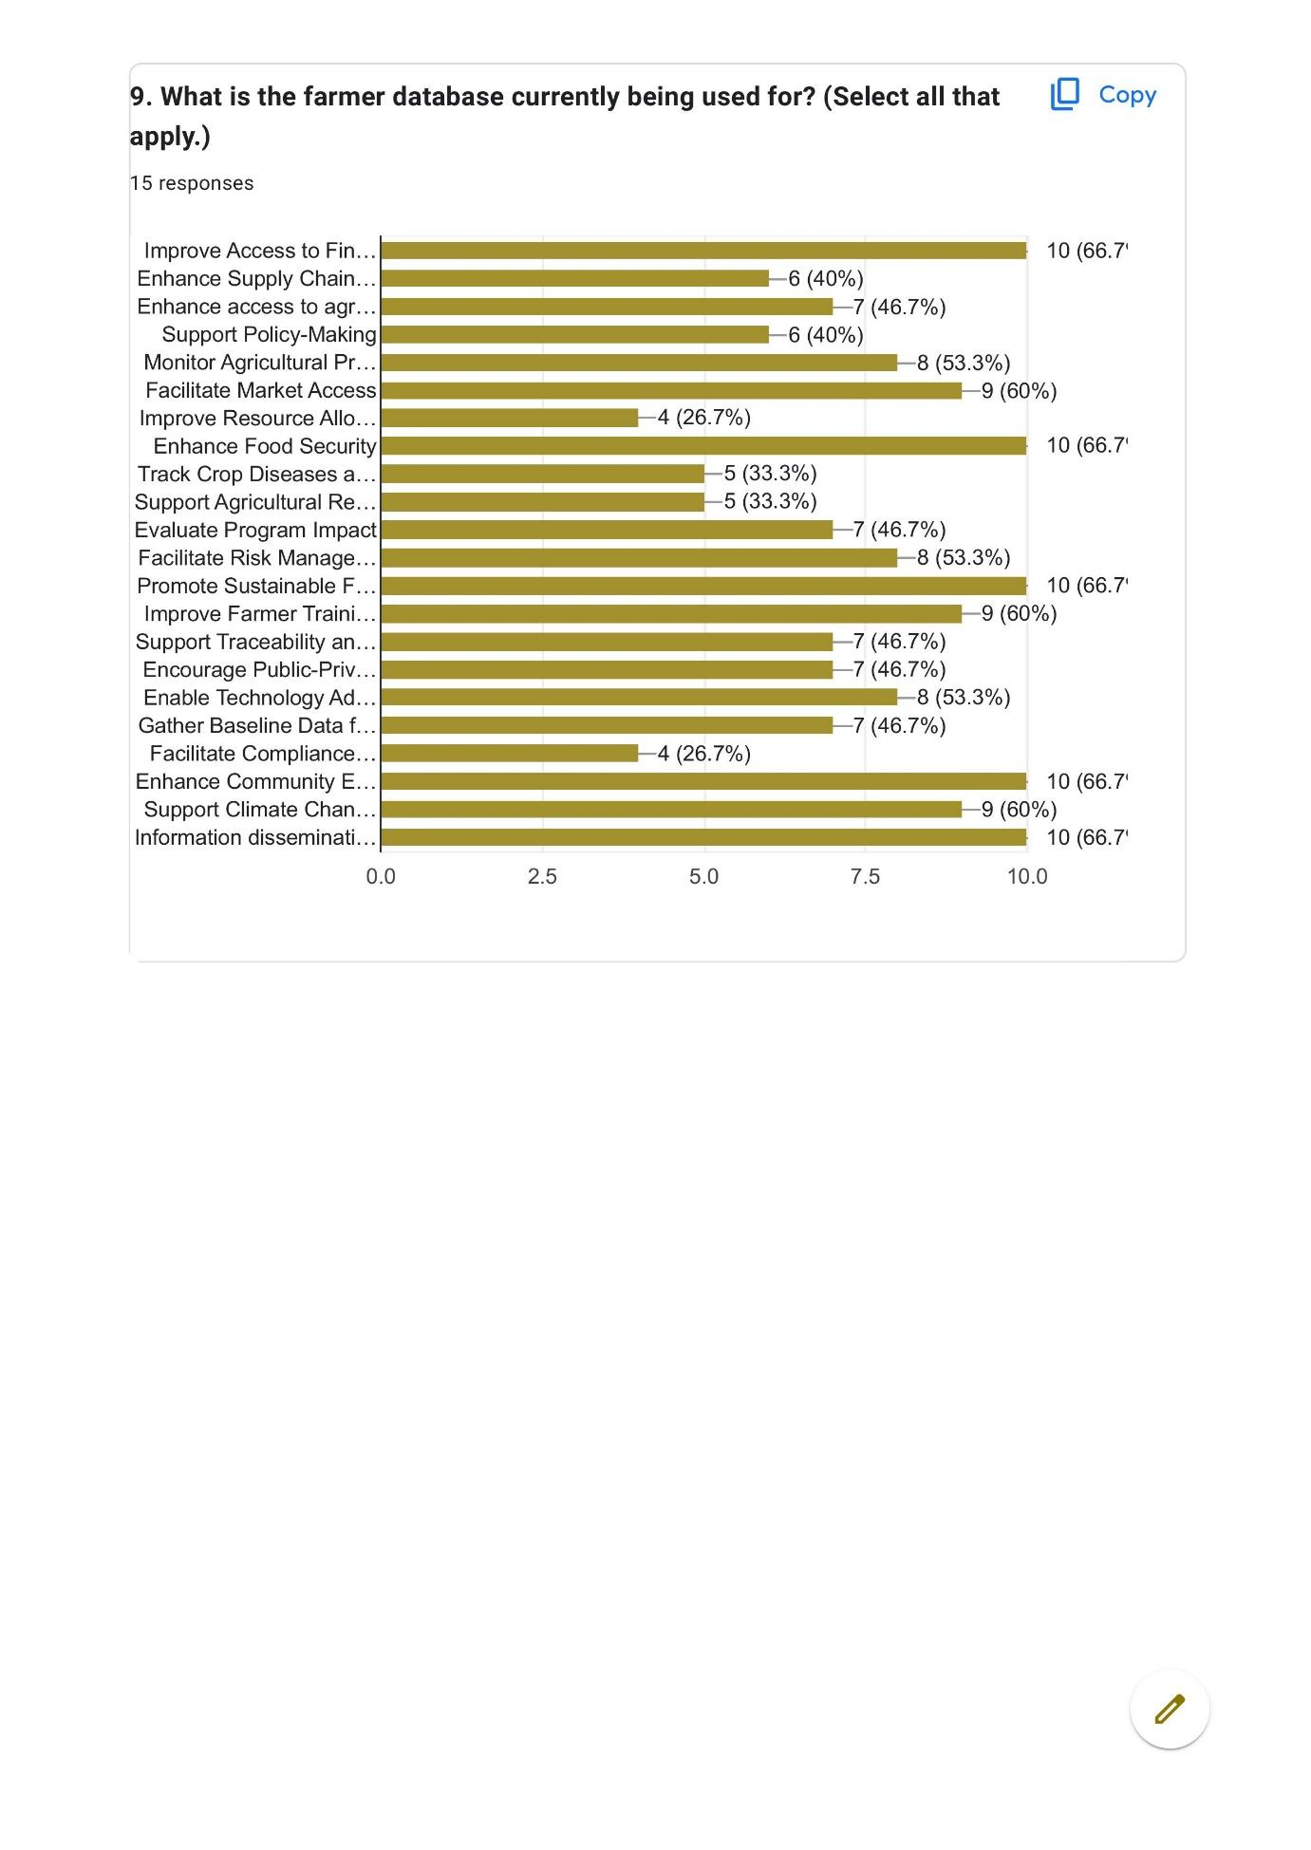
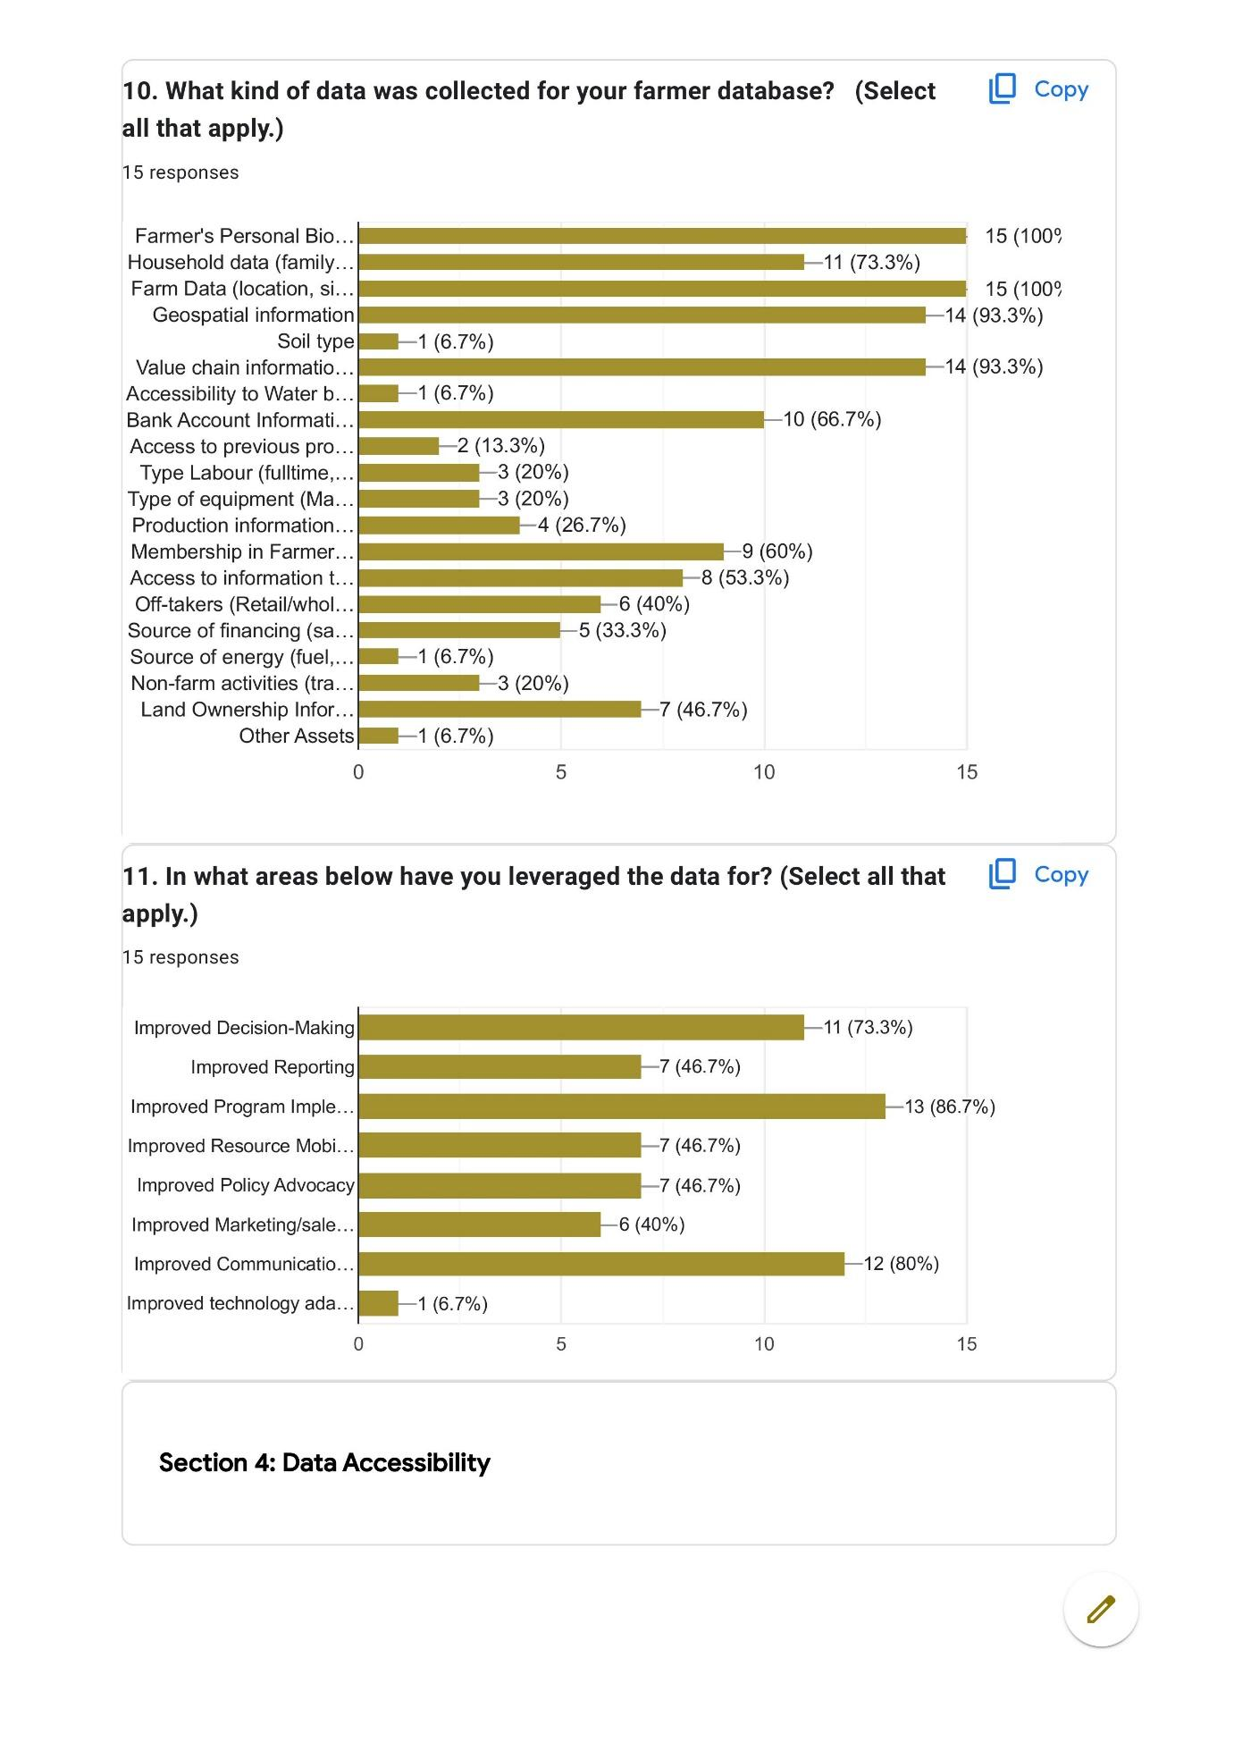
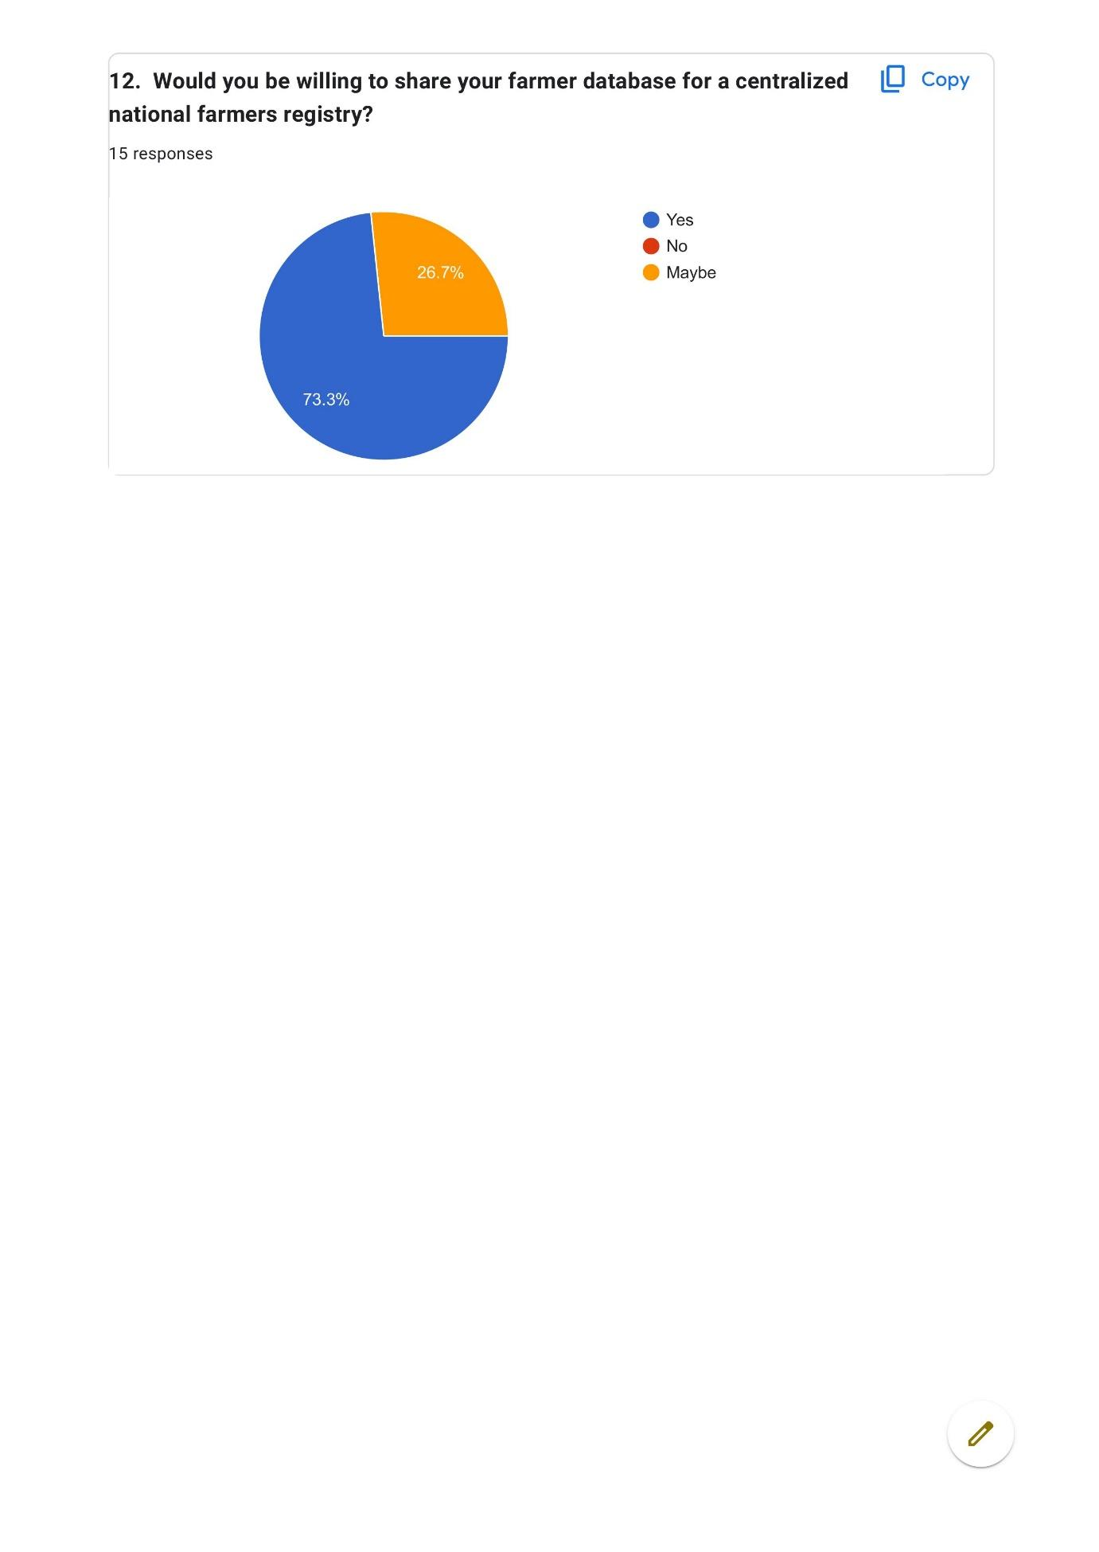

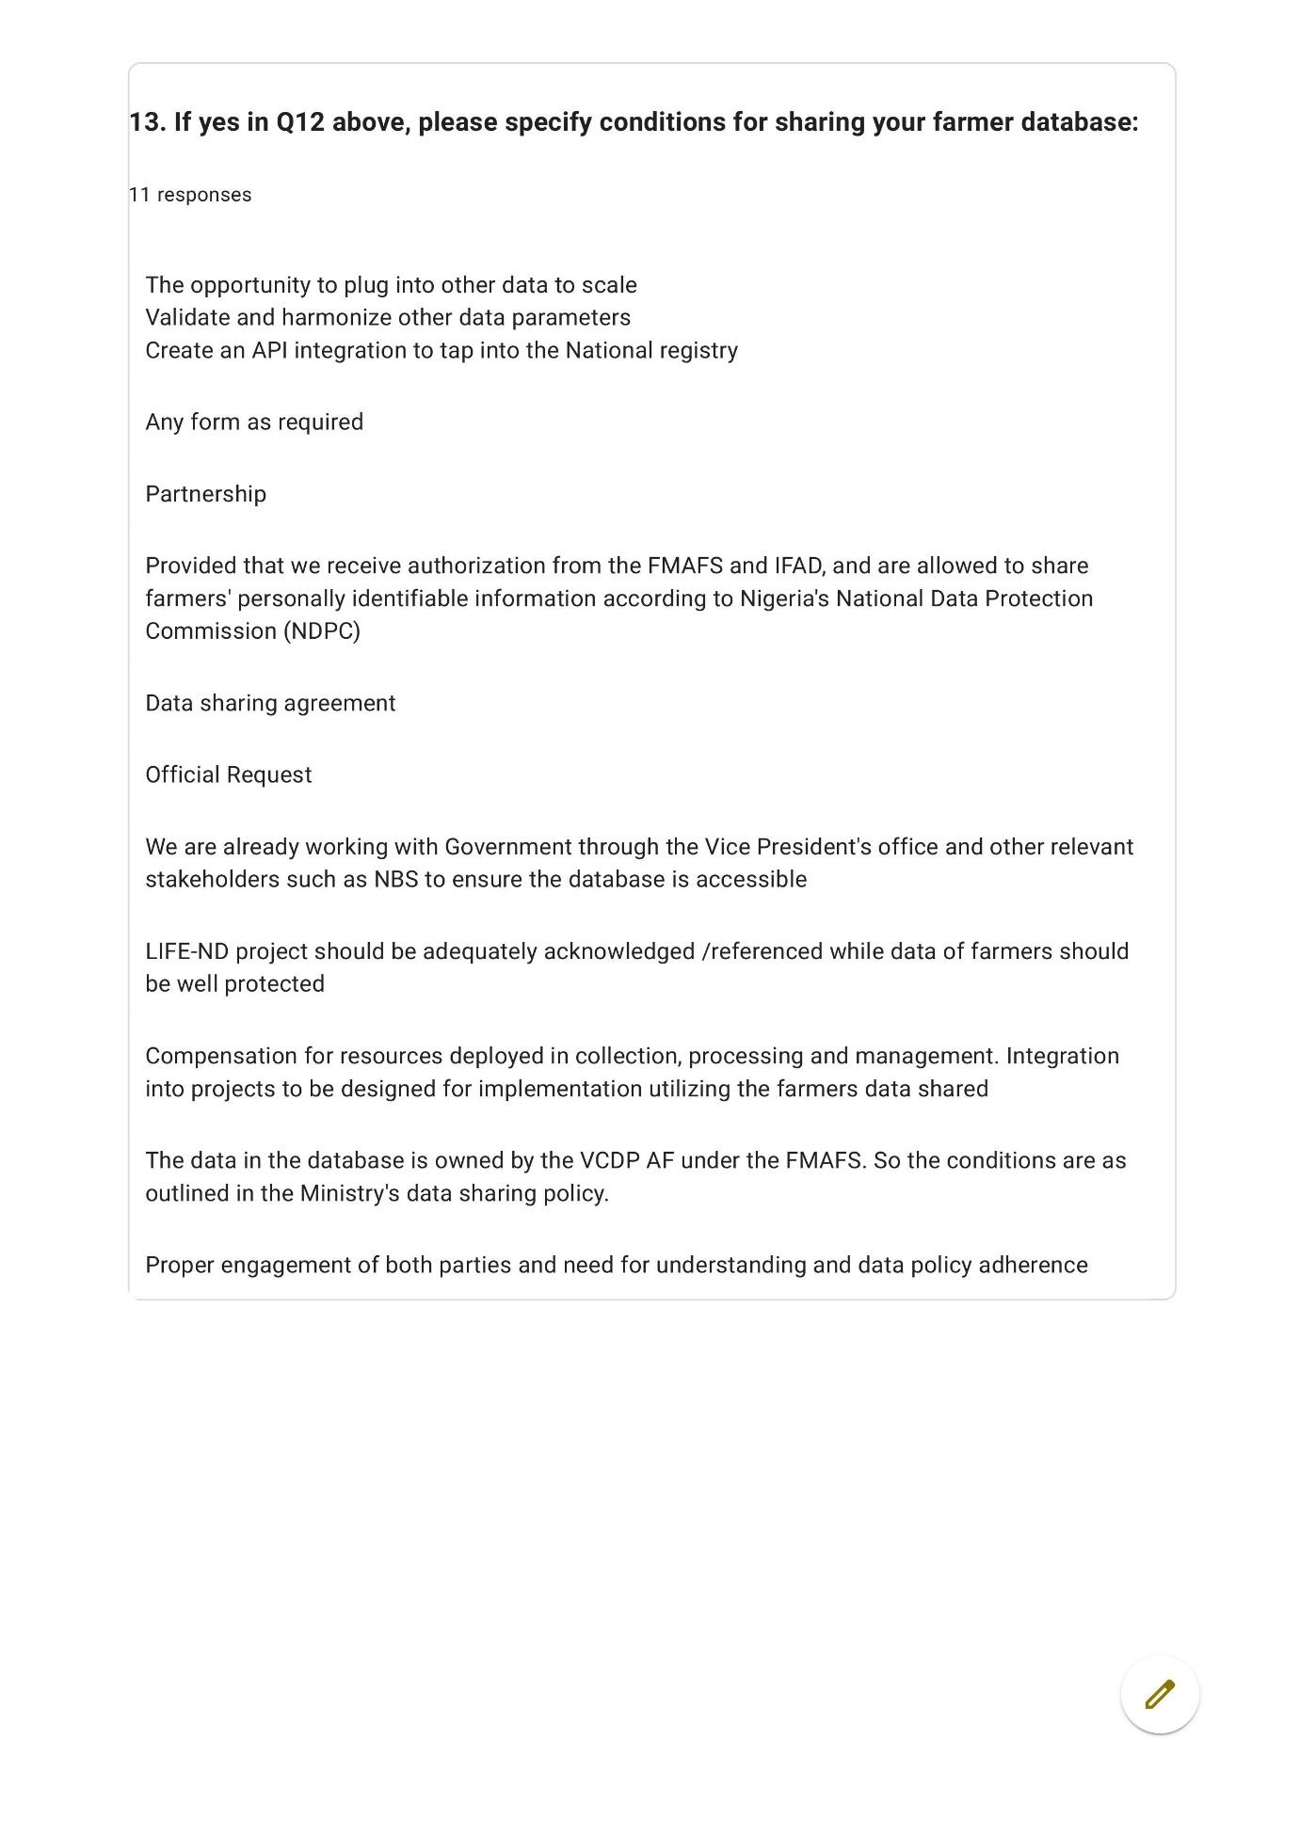
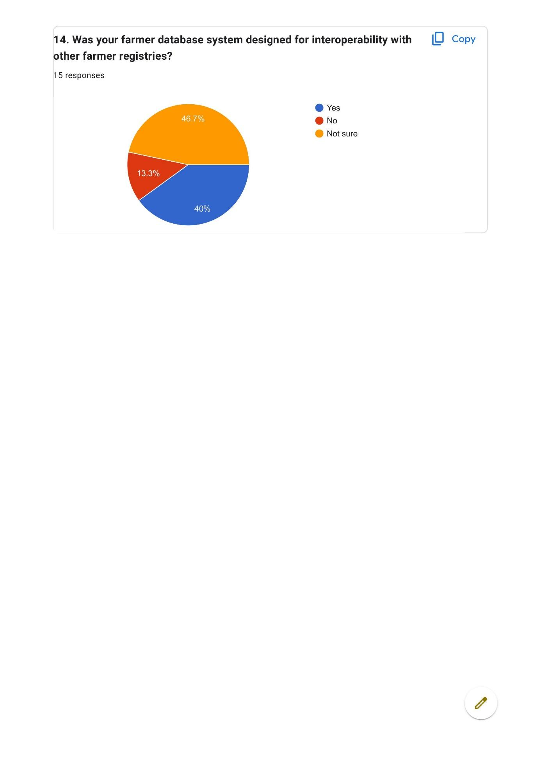
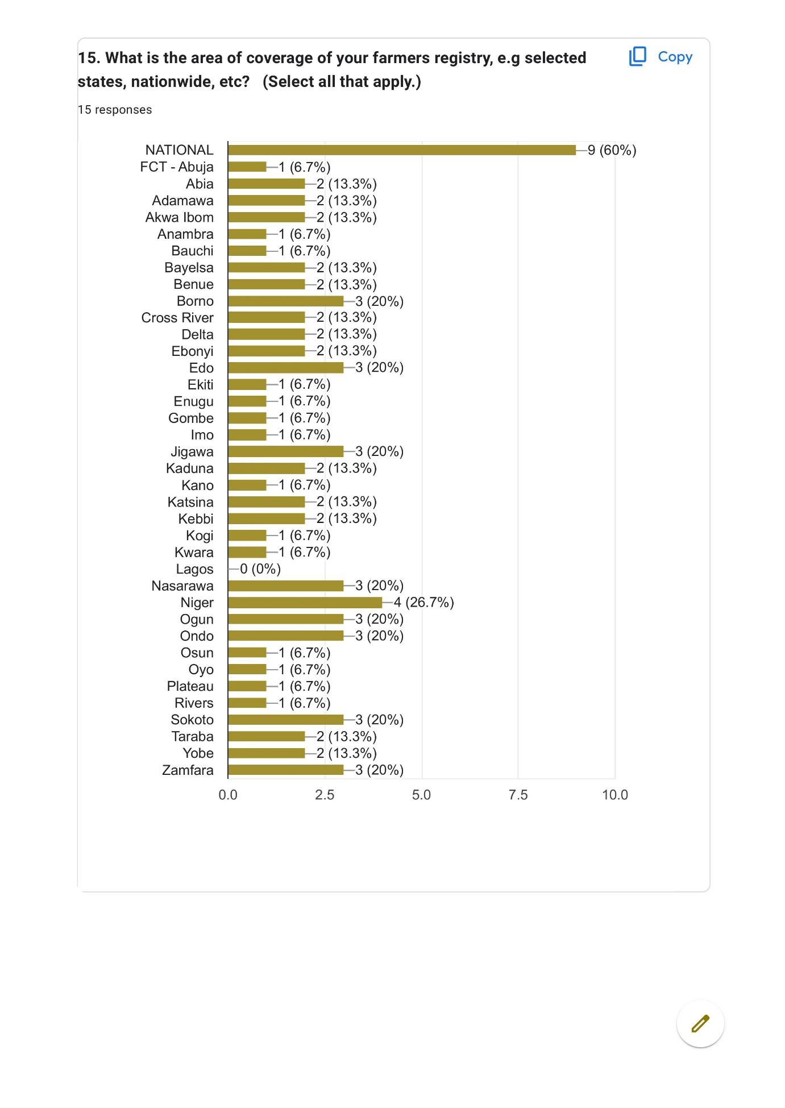
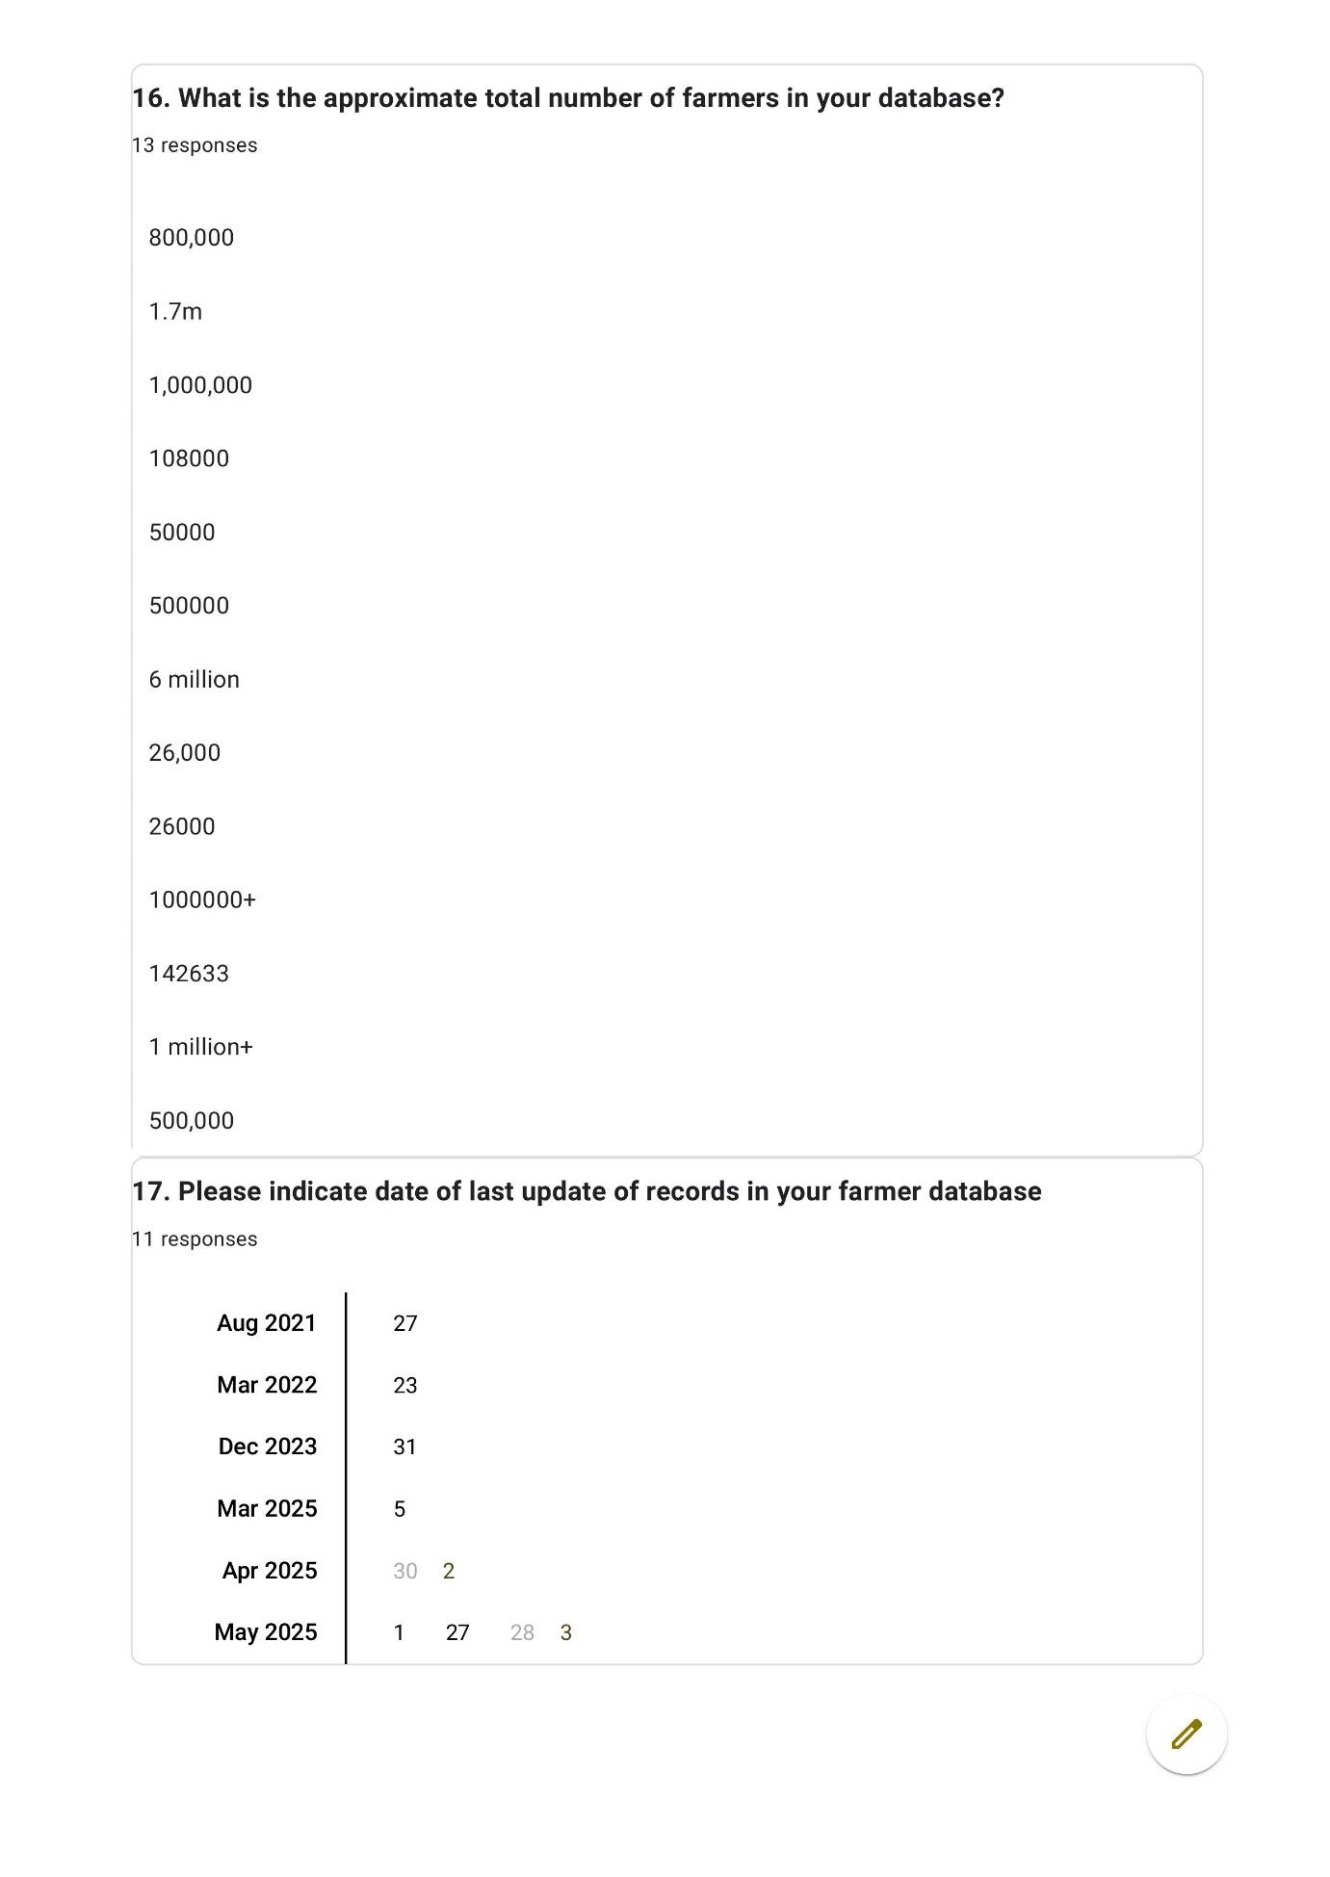
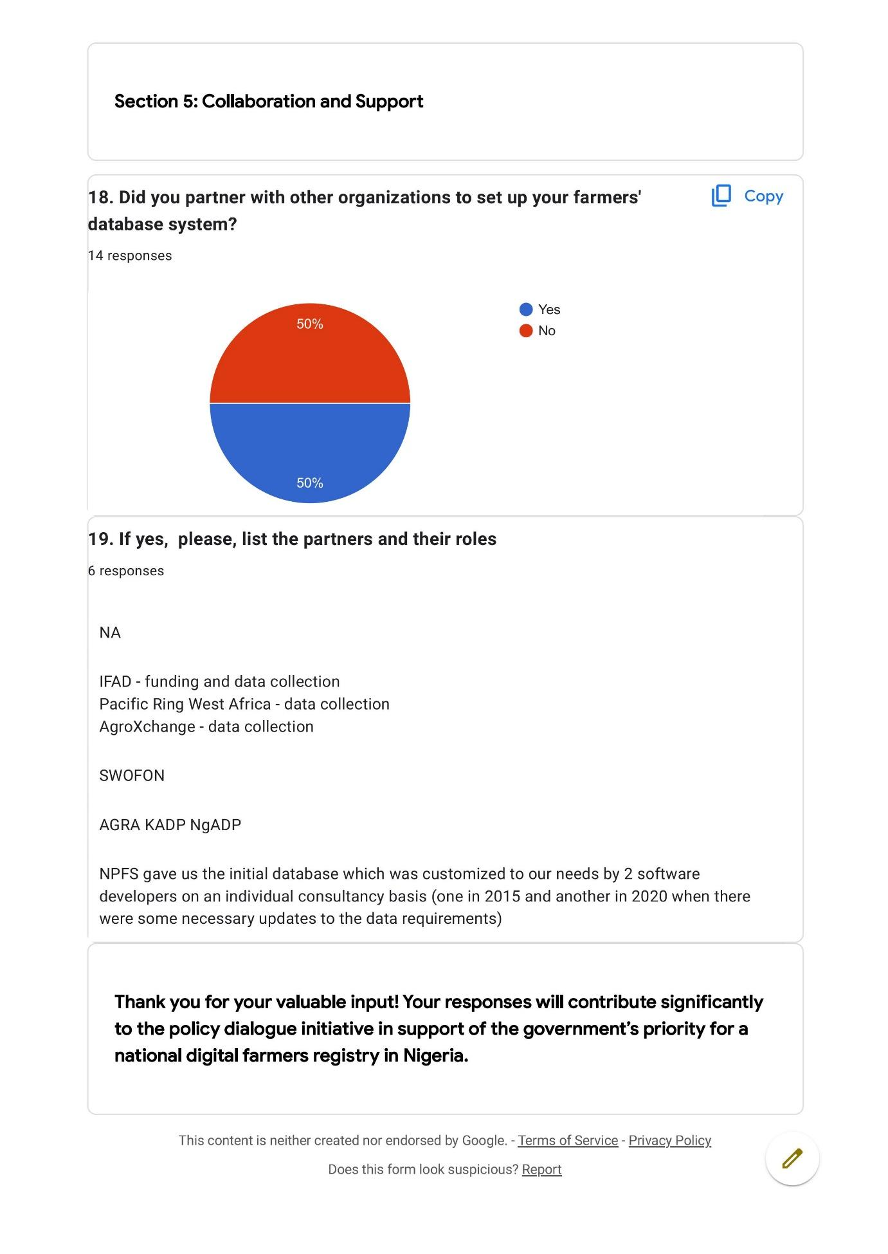

Annex 6 – Workshop Attendance
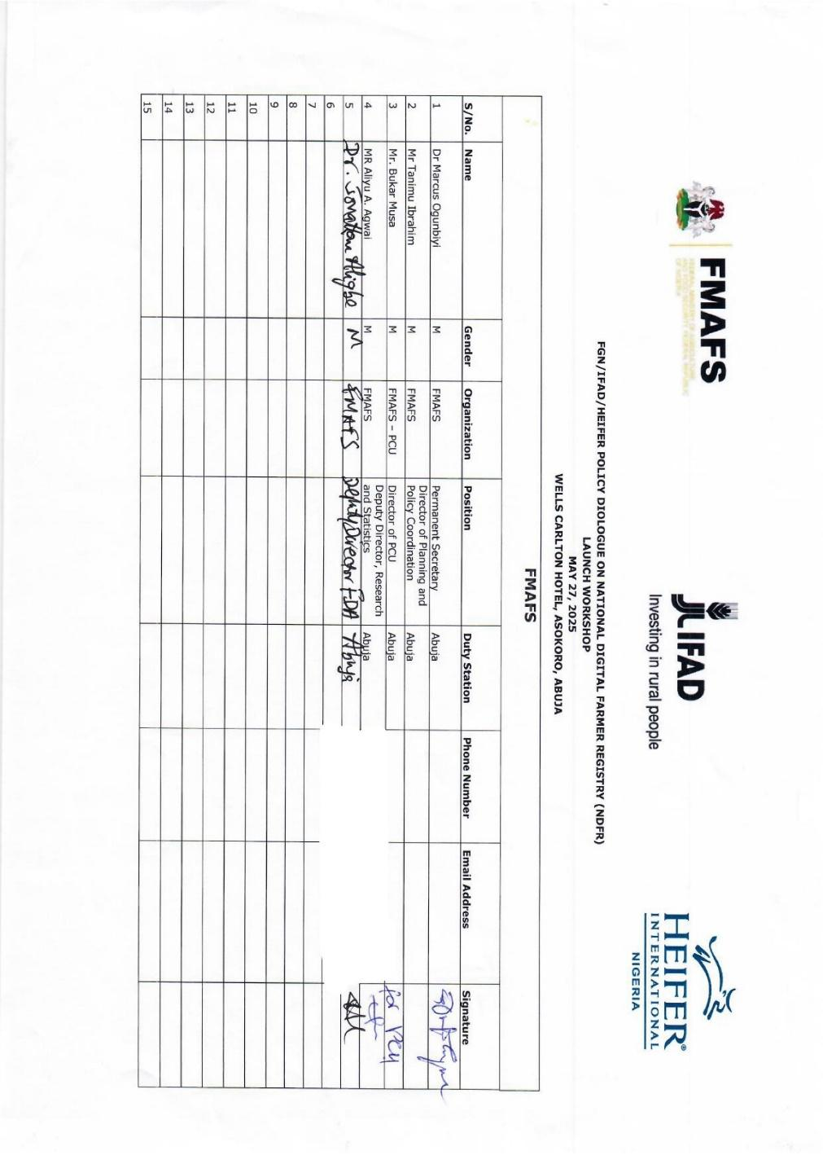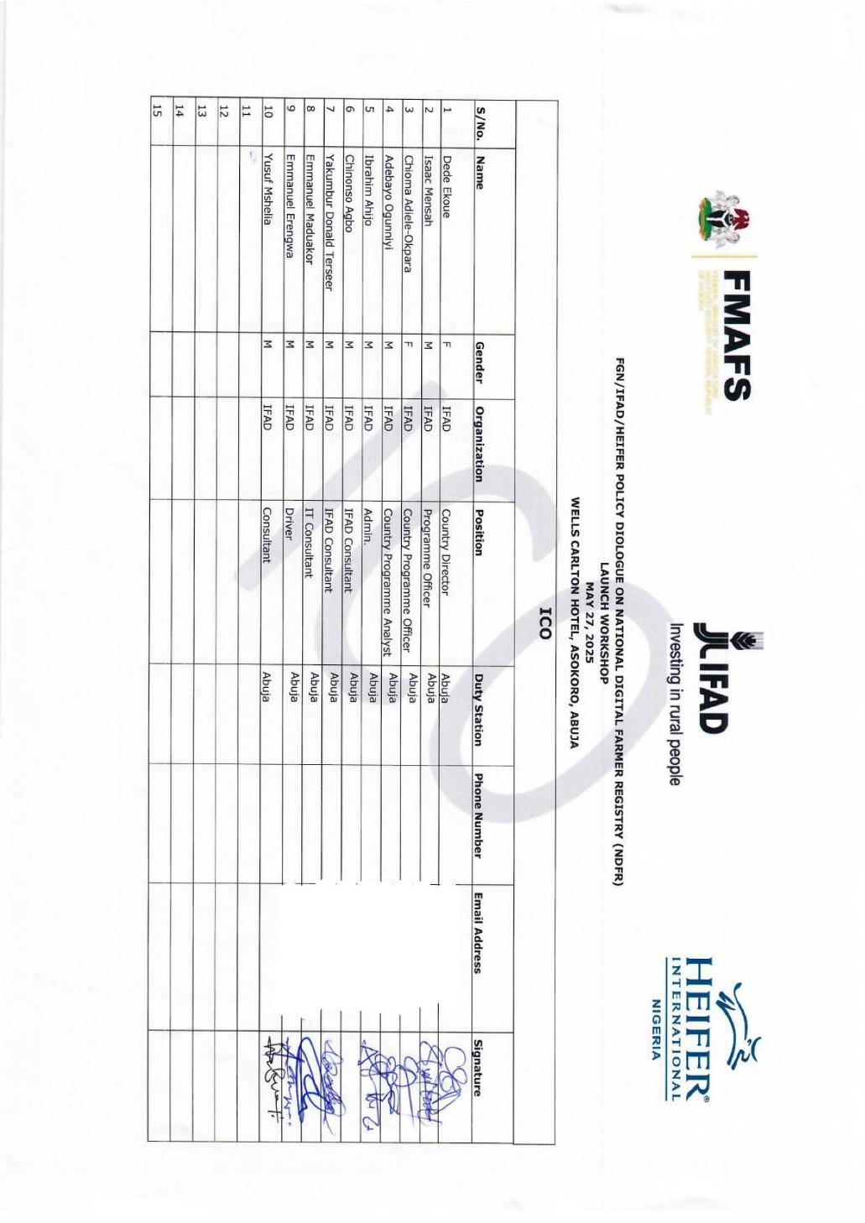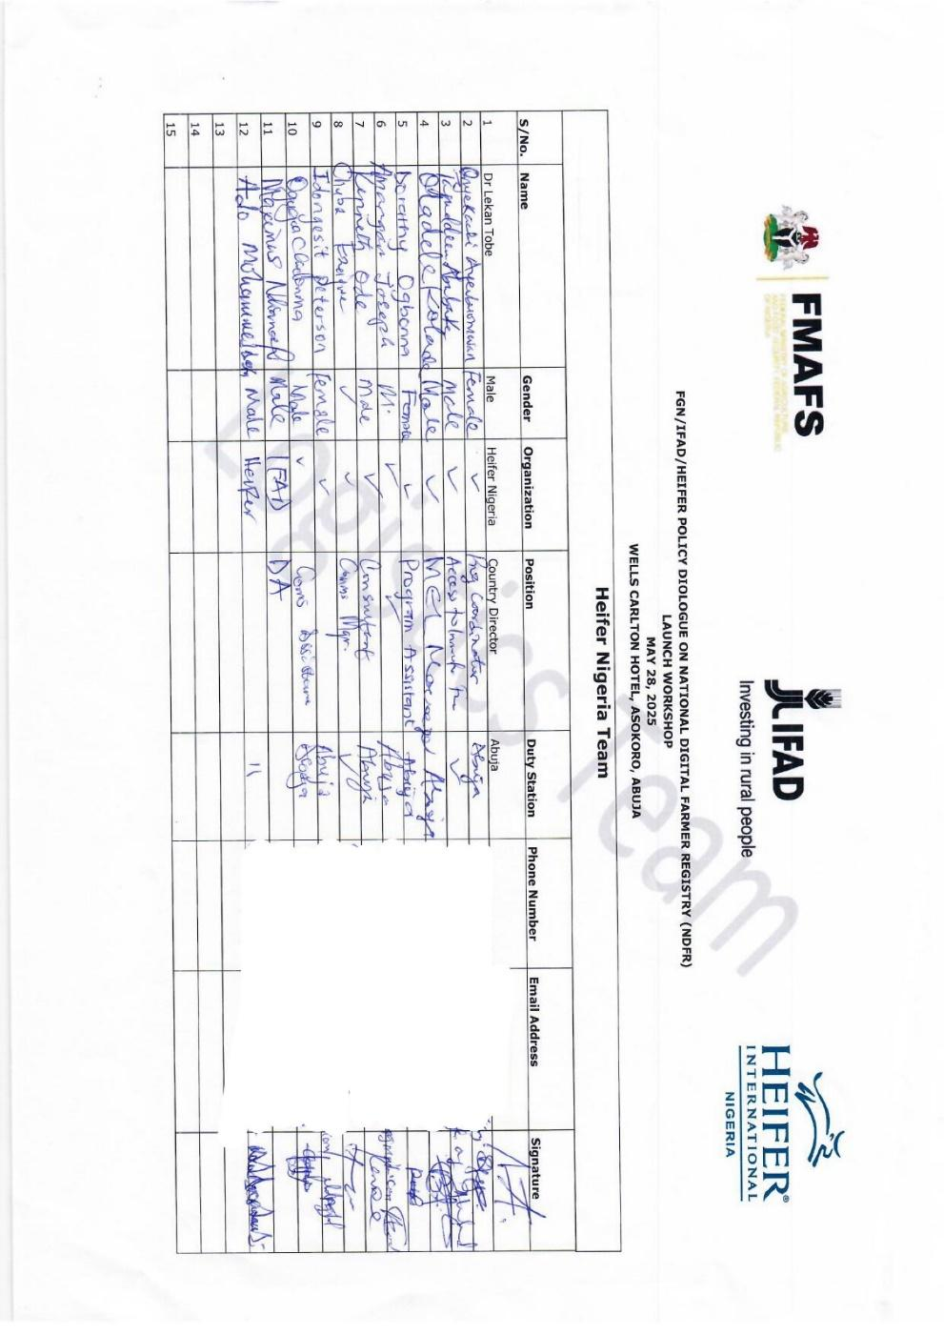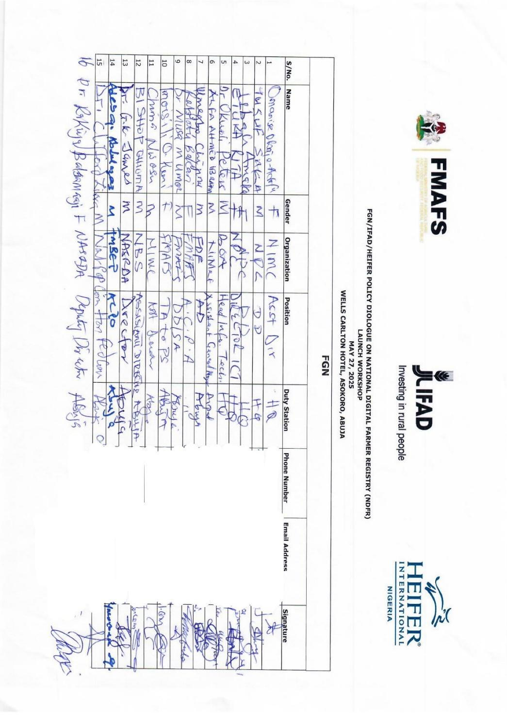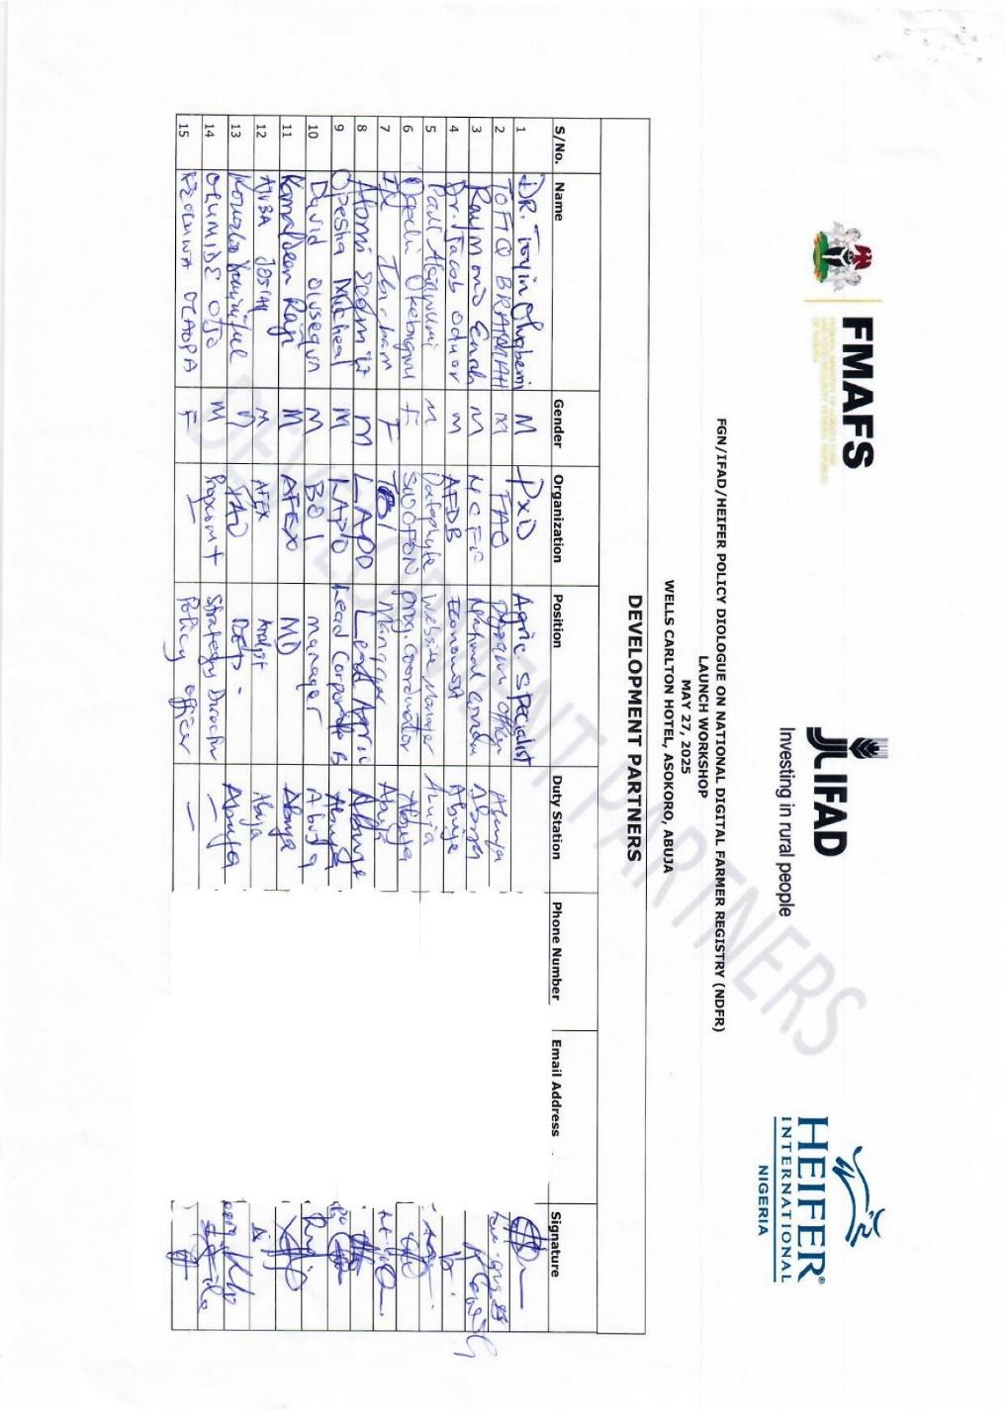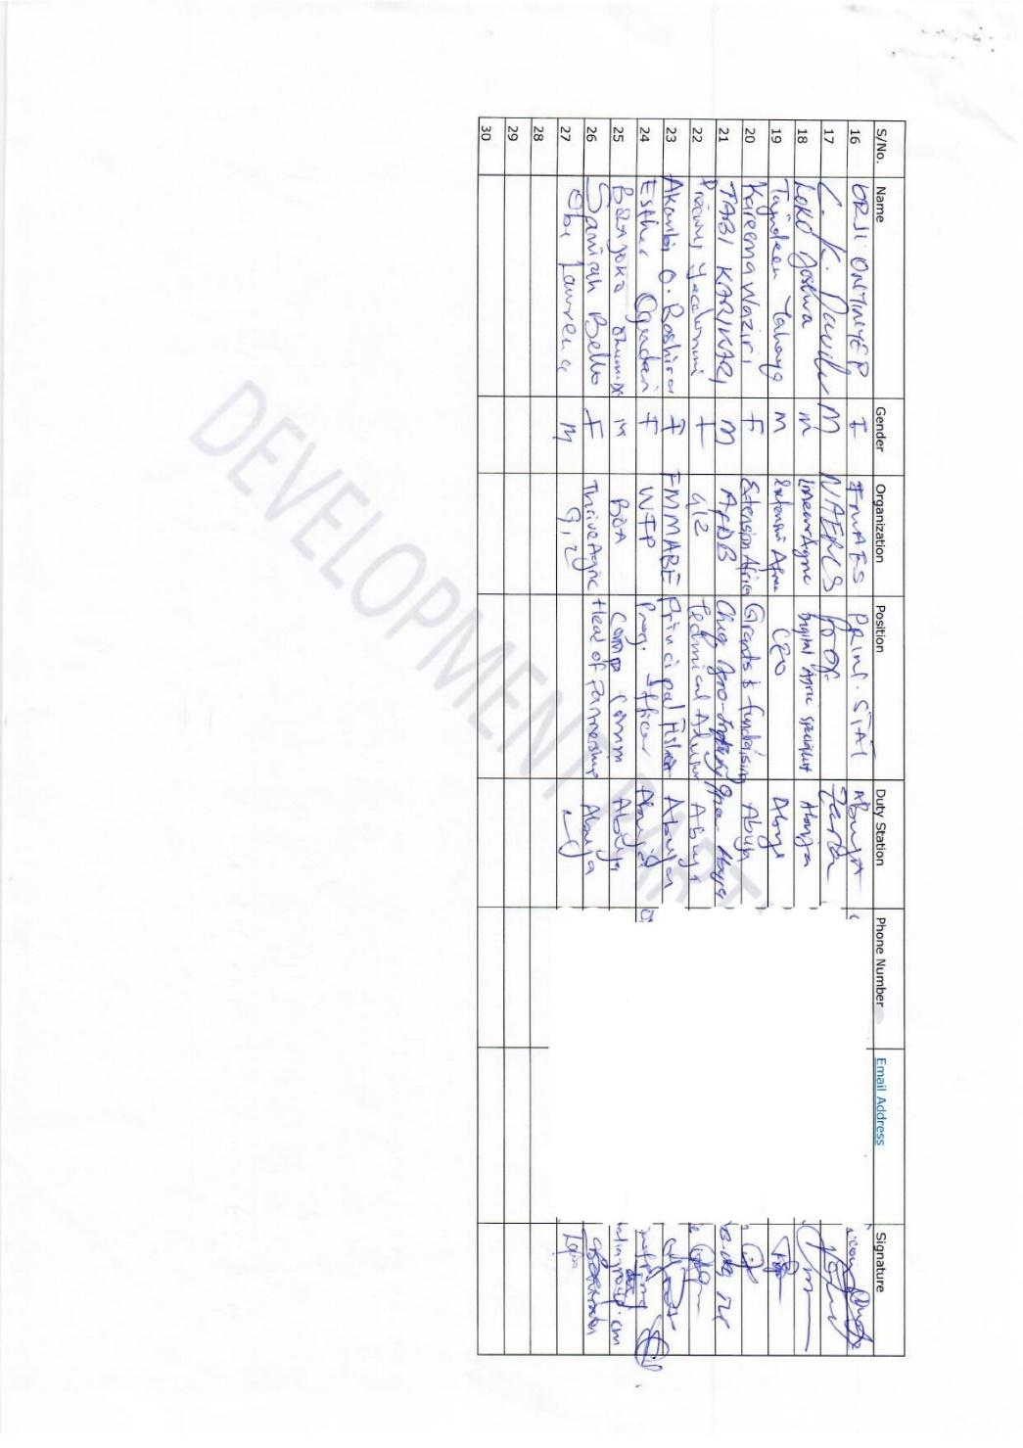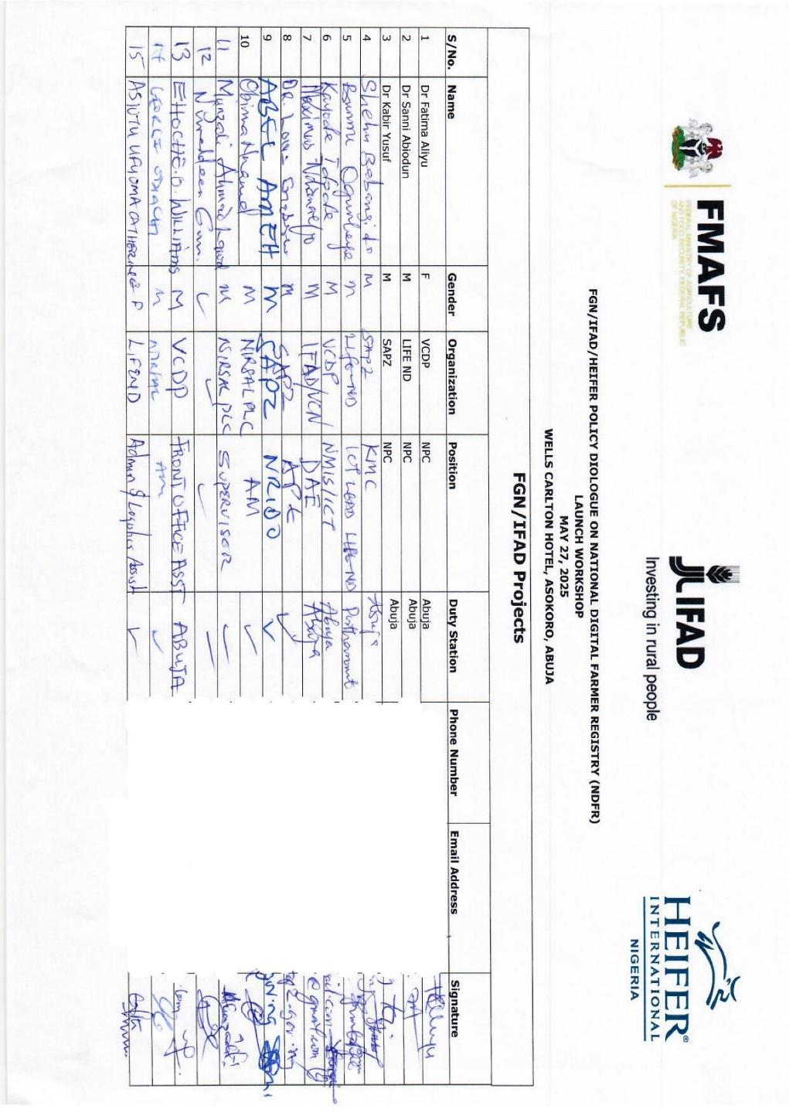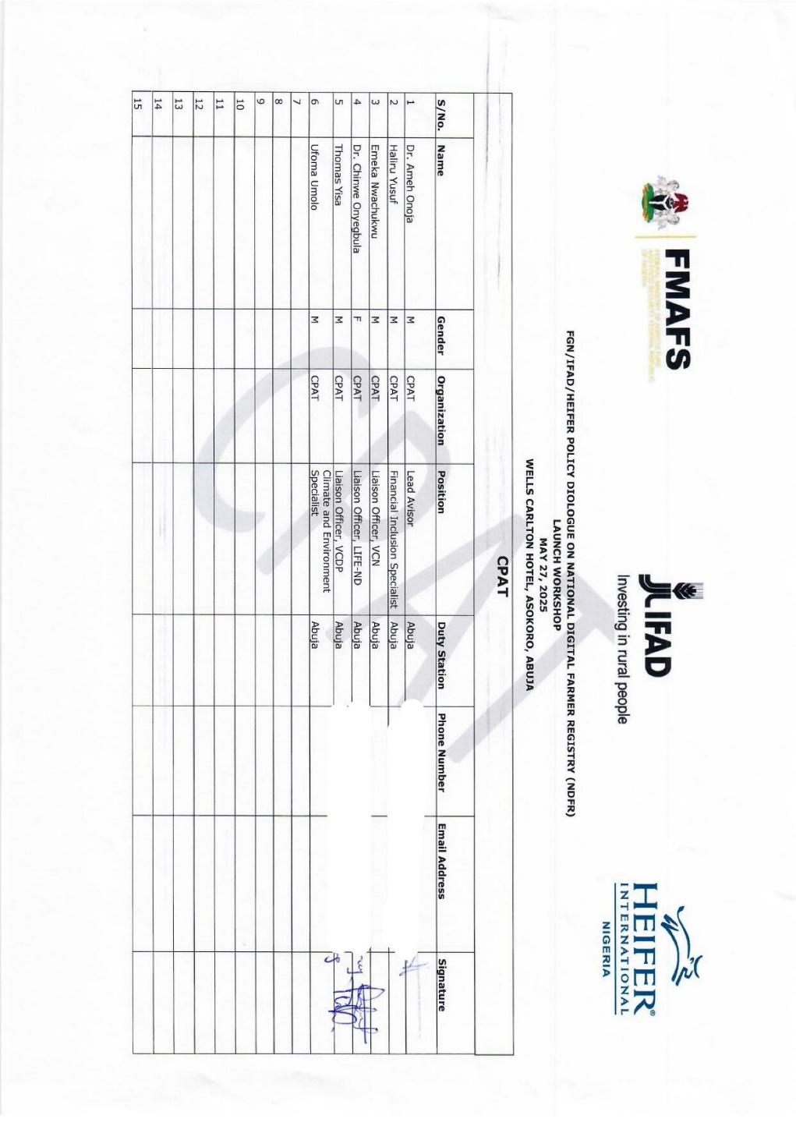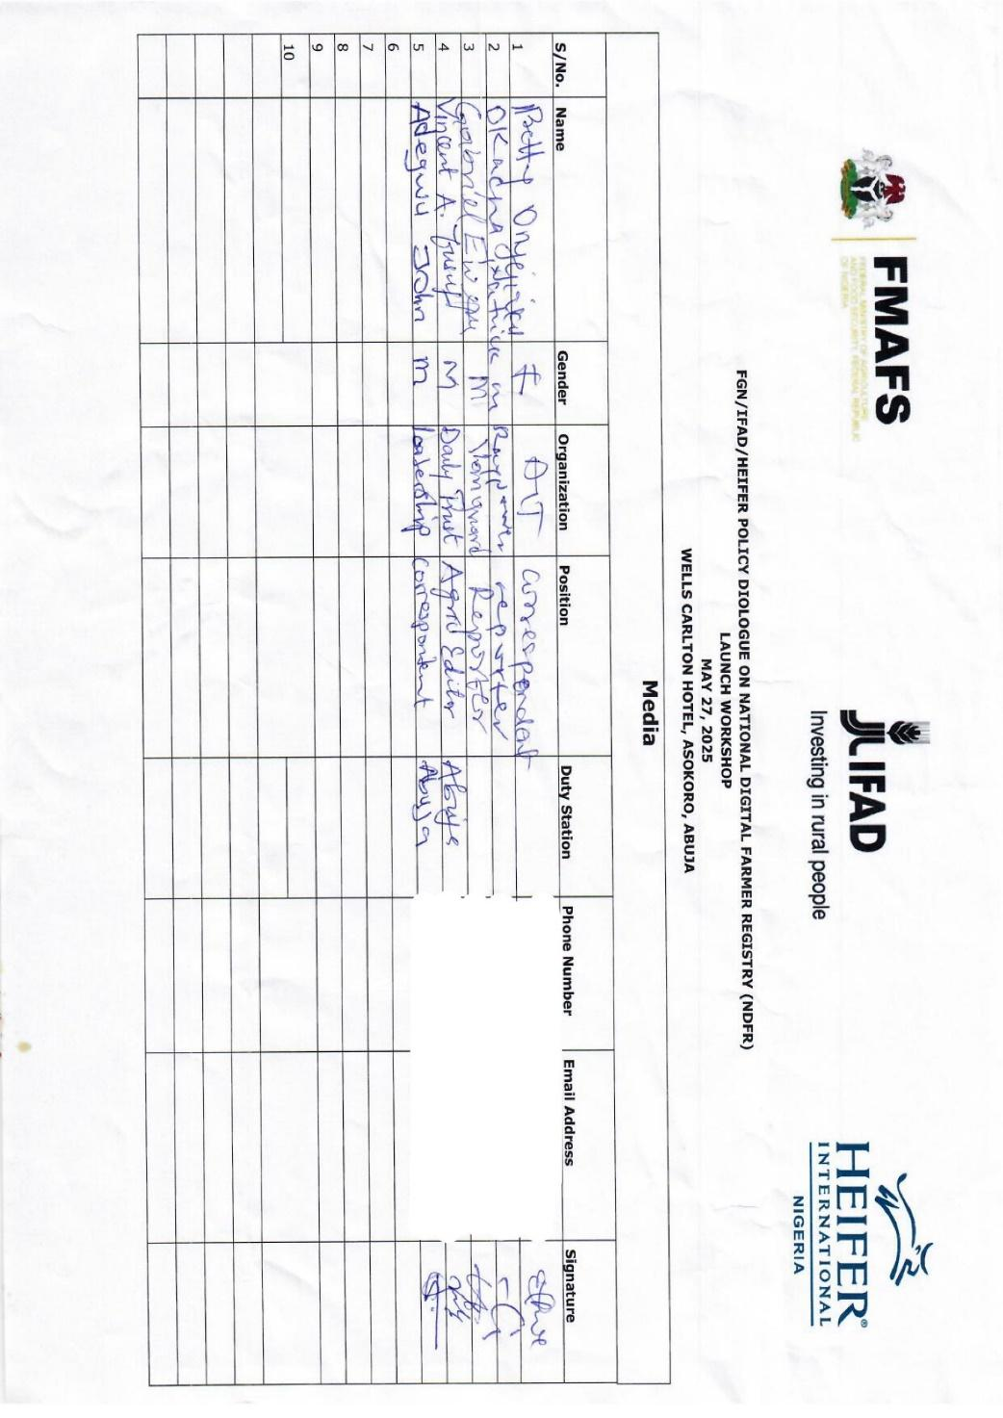

See full list of attendance list in Annex 6
https://rr-africa.woah.org/app/uploads/2025/01/REV_ENGLISH-Draft-Kampala-CAADP-Declaration-January-10-2025-FT-C.pdf
https://agriculture.gov.ng/wp-content/uploads/2024/06/National-Agricultural-Technology-and-Innovation-Policy-NATIP-2022-2027.pdf
https://drive.google.com/file/d/1MrjS3Q2Vr63gmDMw8Rcp5dg_b99pRqye/view?pli=1
https://drive.google.com/file/d/1cV3nN0IsBmSUUAd1xp2Gi9R1GTtahiaf/view?pli=1

